### 

### 

**1.0 Setting up AWS Database** **3**

1.1 Setting up AWS Lambda 12

1.2 Setting up AWS API Gateway 15

**2.0 Setting up Firebase** **26**

2.1 Setting up Firebase Authentication 27

2.2 Setting up Firebase Database 31

2.3 Setting up Firebase Storage 33

2.4 Setting up Firebase Hosting 35

2.5 Integrating Firebase into Front-End/Back-End 39

**3.0 Setting up Beacon Direction (Bearings)** **42**

### 

### **1.0 Setting up AWS Database**

Before setting up AWS, you must sign up for an AWS Account if you do not have one.

**Step 1 -** Login to AWS Server

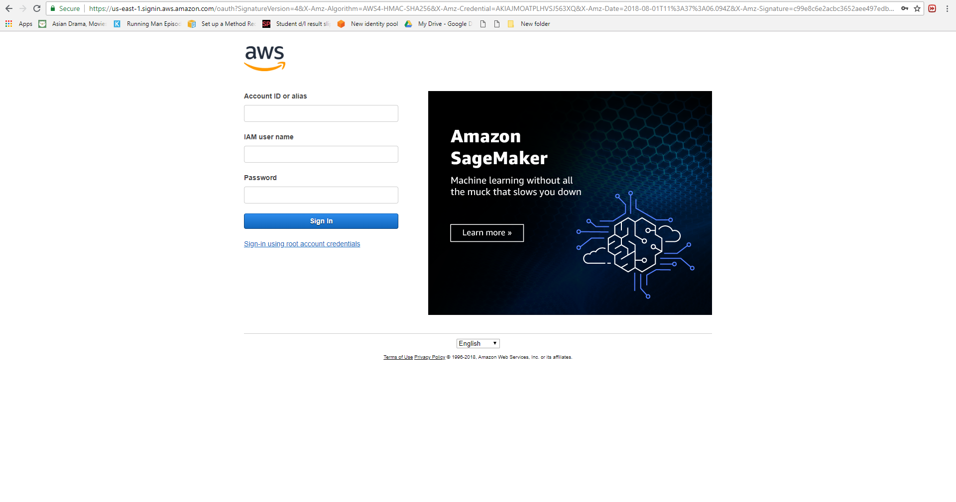

Go to<https://aws.amazon.com/console/>.

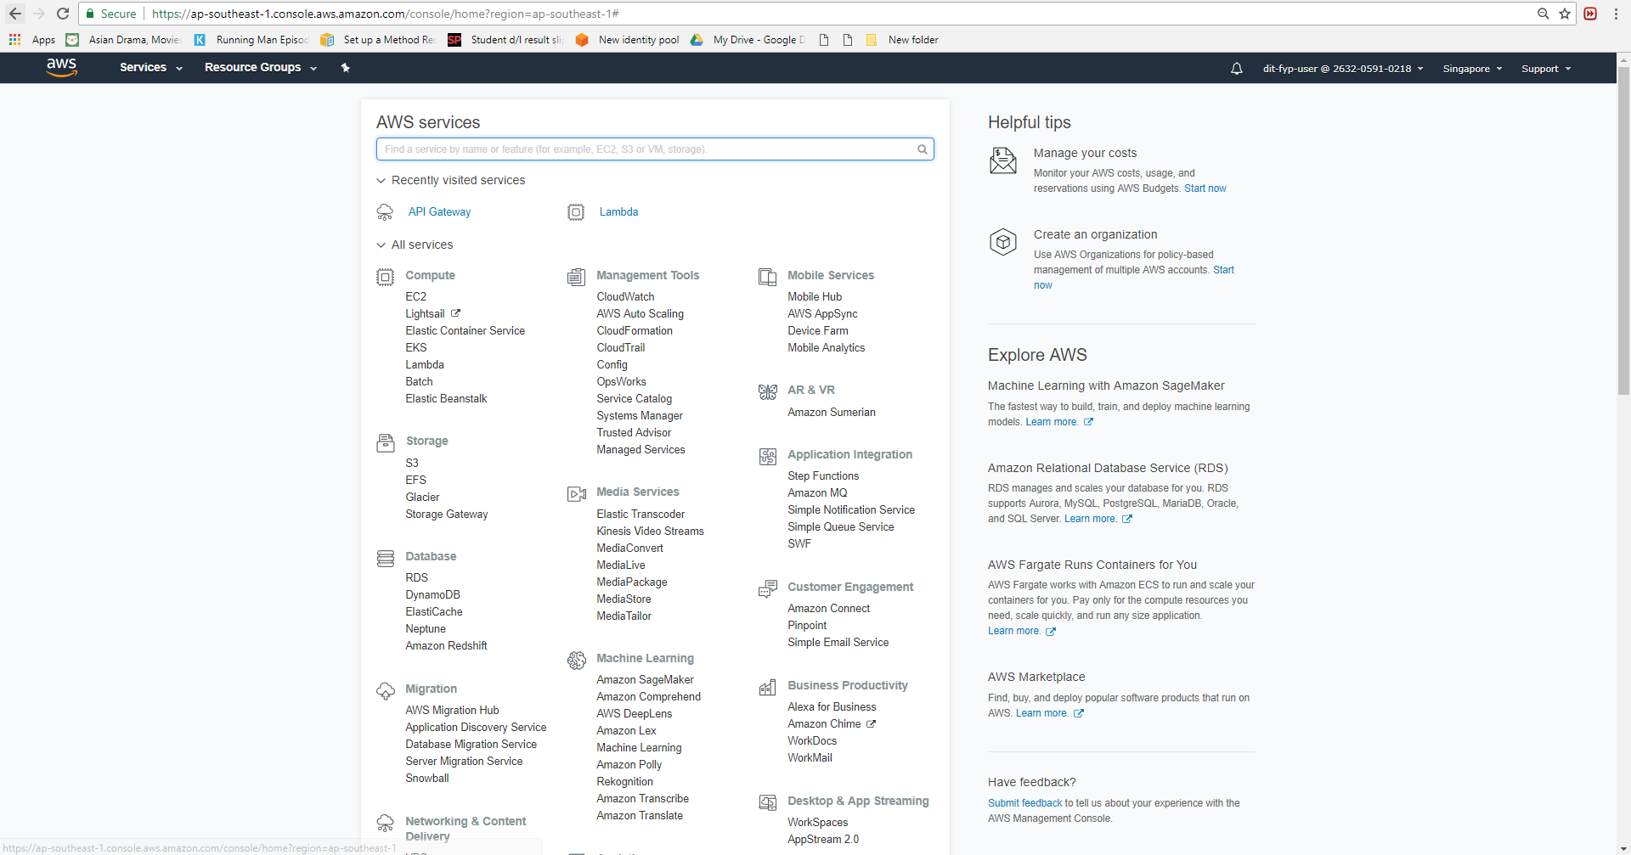

You should be redirected to the AWS console page.

**Step 2 -** Click on RDS under the “Database” category or search “RDS”

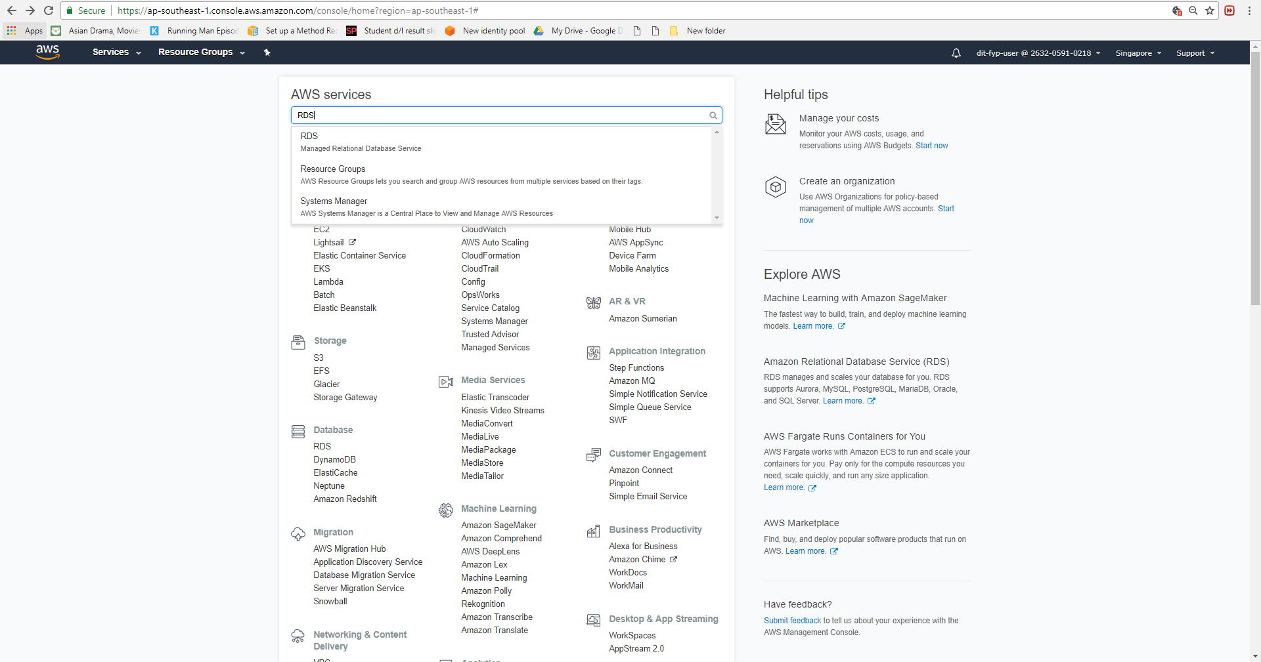

**Step 3 -** Click on instances on the left navigation bar and click on “Create database” button

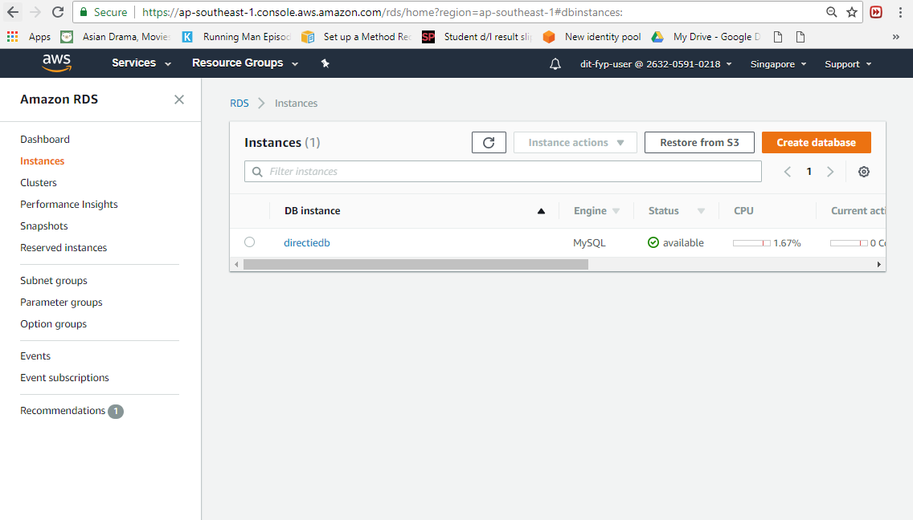

**Step 4 -** Select MySQL and proceed by clicking “Next” button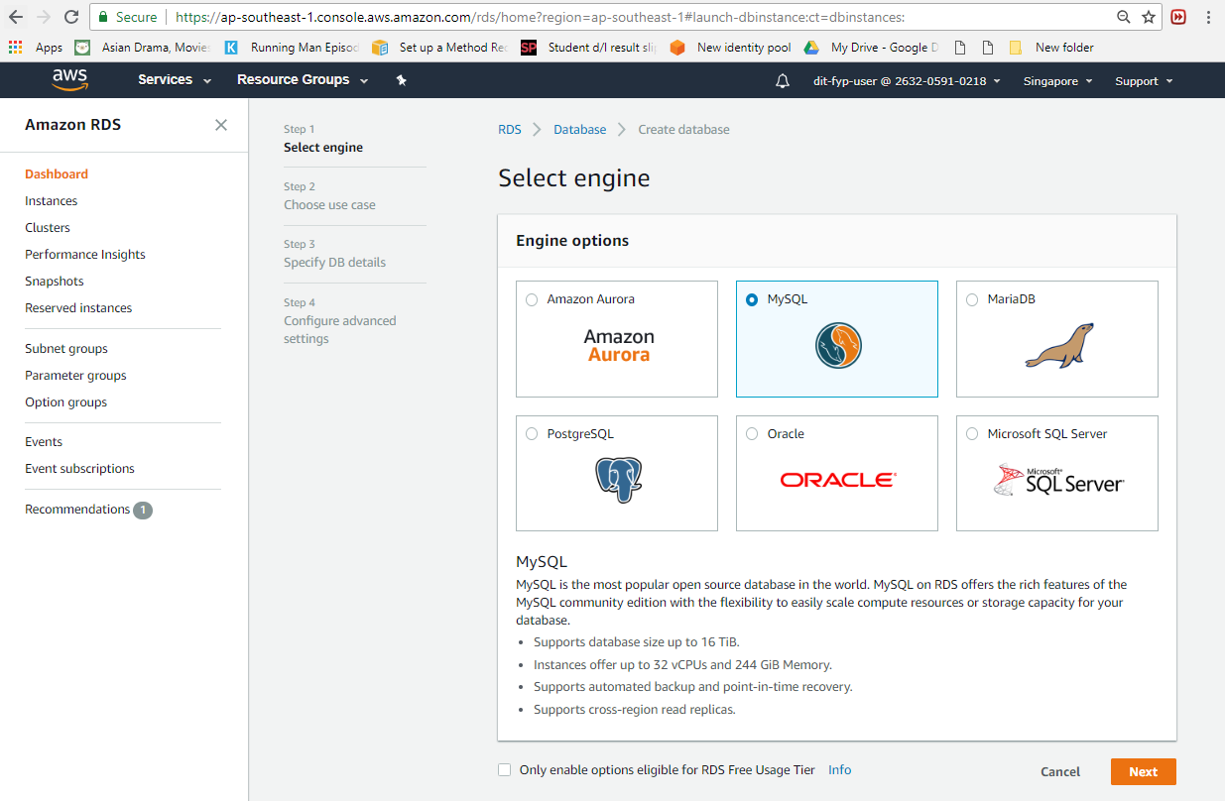

**Step 5 -** Choose Production-MySQL as Use Case and click “Next” button

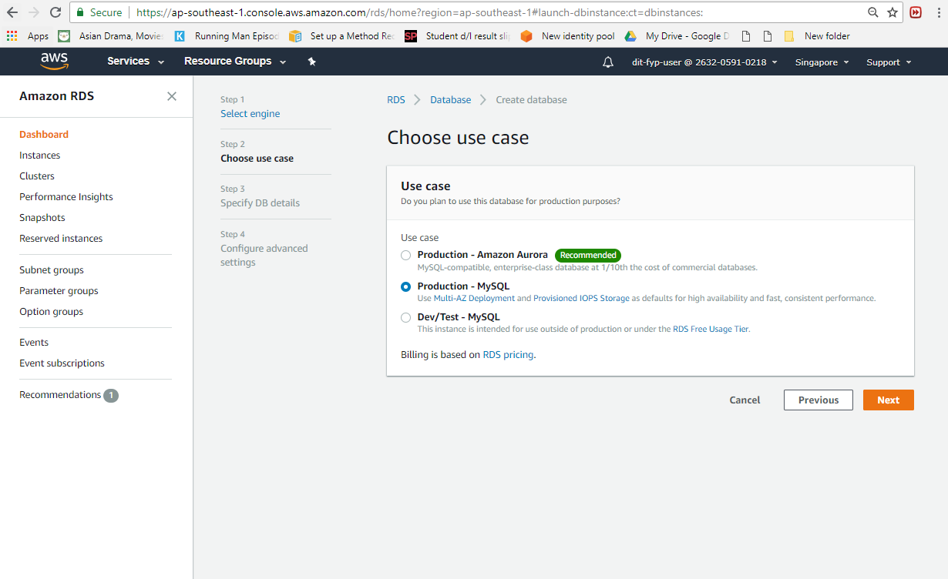

**Step 6 -** Follow the image below for the instance specifications

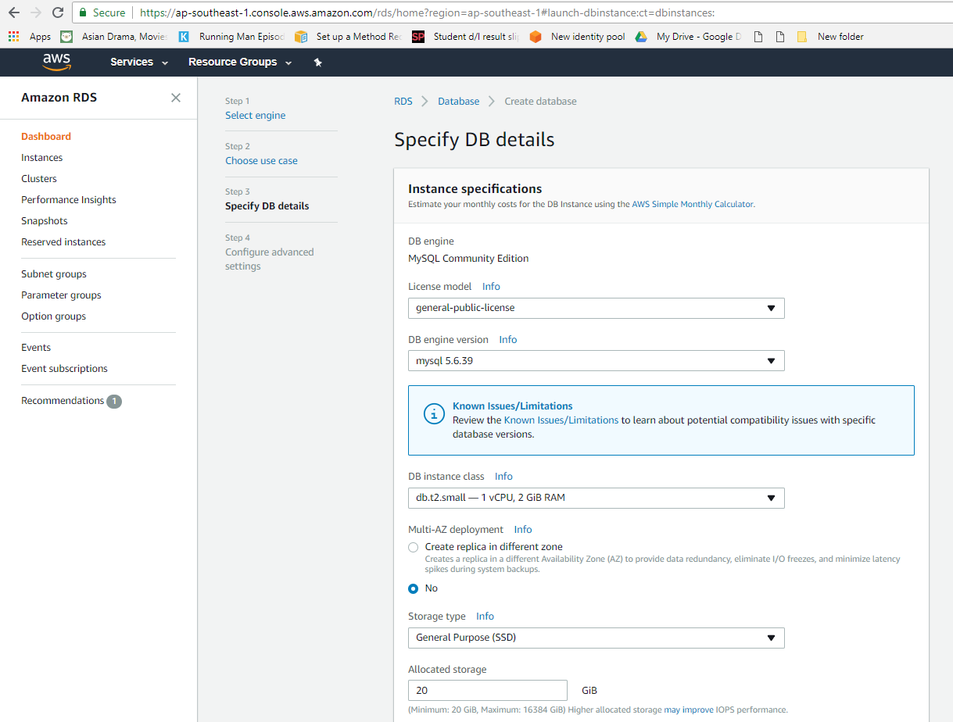

Under settings, enter your DB instance identifier, Master username, password and confirm password then click “next” button

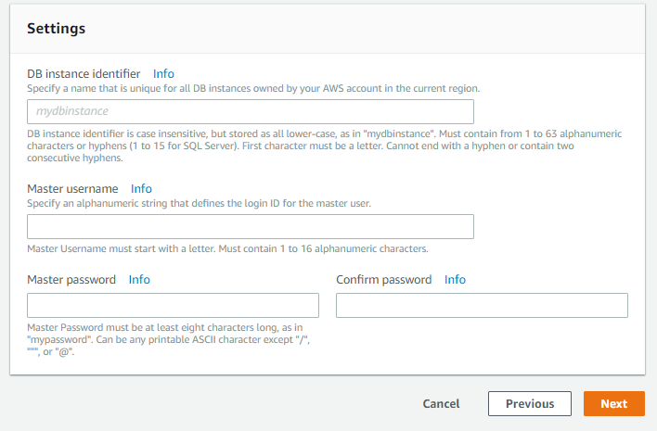

**Step 7 -** Follow the image below for advance settings and then click “create database” button

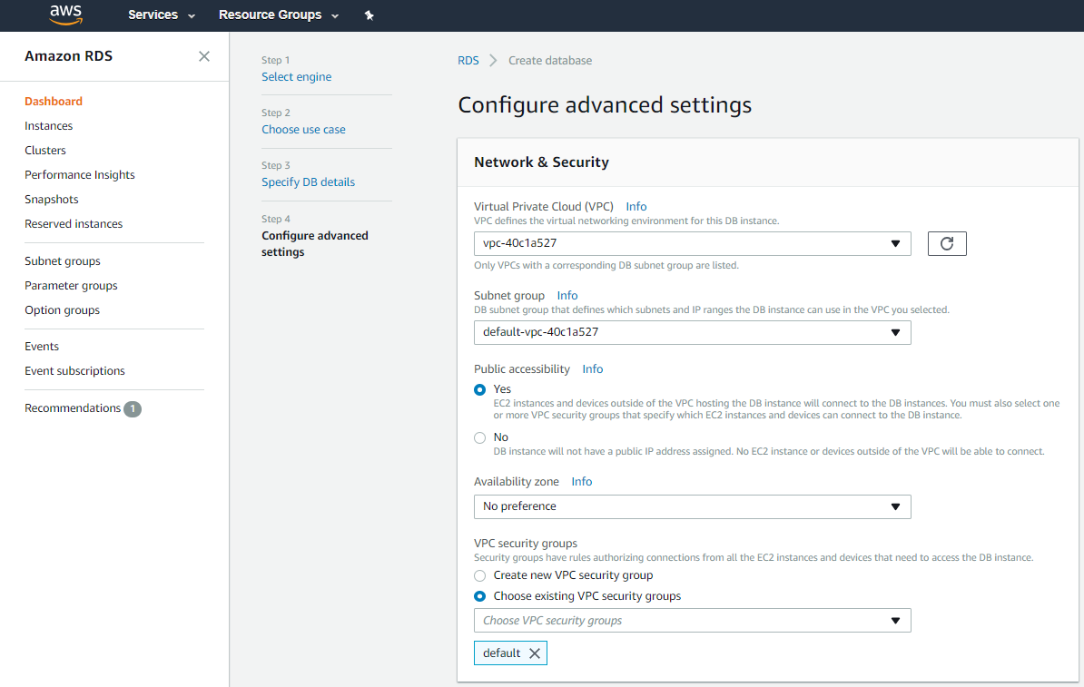

For VPC and subnet group select default and for VPC Security Group, create new or use existing one to allow connection from the IP address of your device to the database.

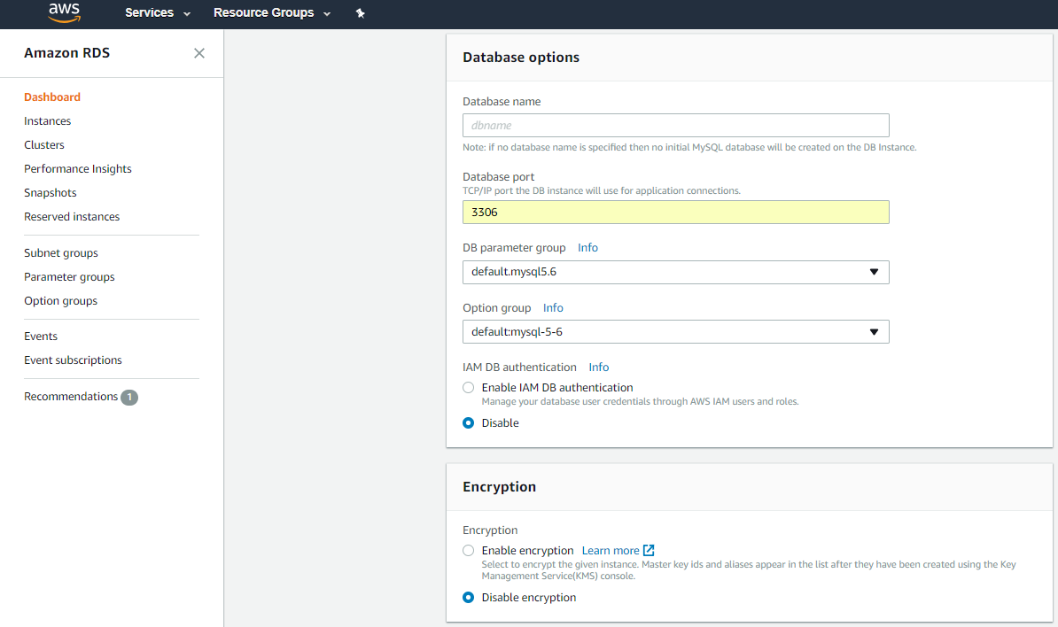

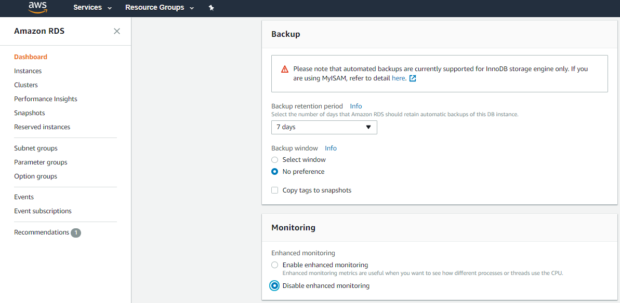

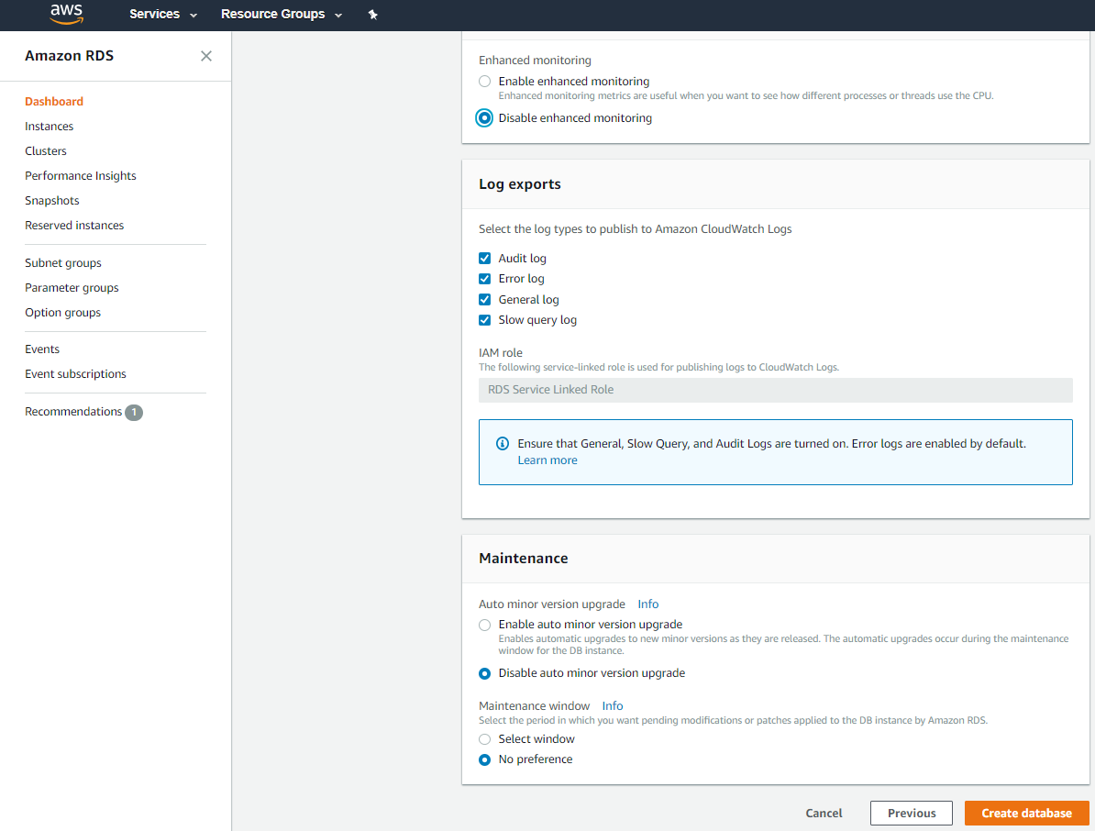

**Step 8 -** Go back to instances to view the database you have just created and click on the instance you created

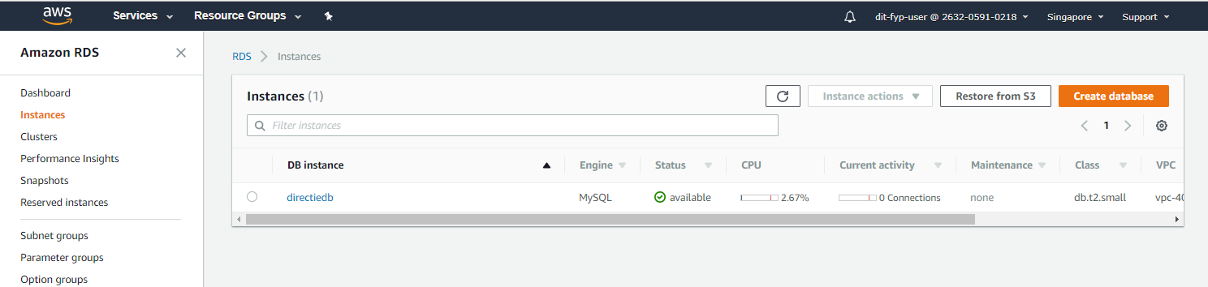

**Step 9 -** Copy the Endpoint from your AWS RDS instance 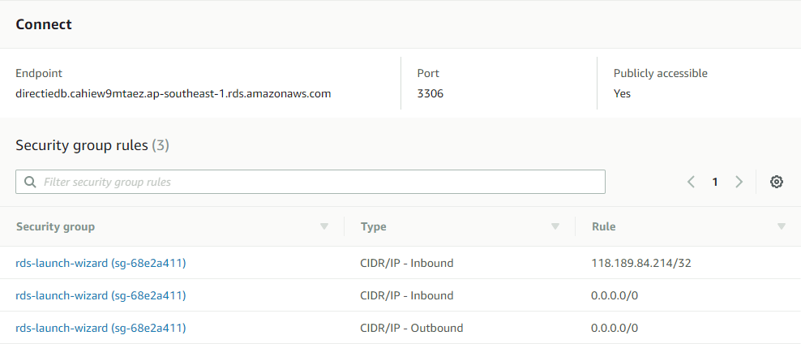

**Step 10 -** Open MySQL Workbench and create a new MySQL Connections by clicking on the plus button

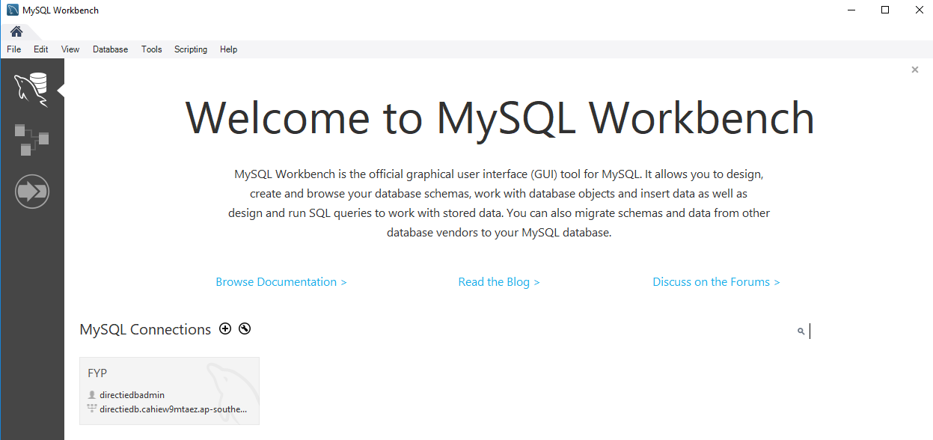

**Step 11 -** Enter your Connection Name and paste the Endpoint in the Hostname. For username and password enter the one you set in step 6 and click “OK” button

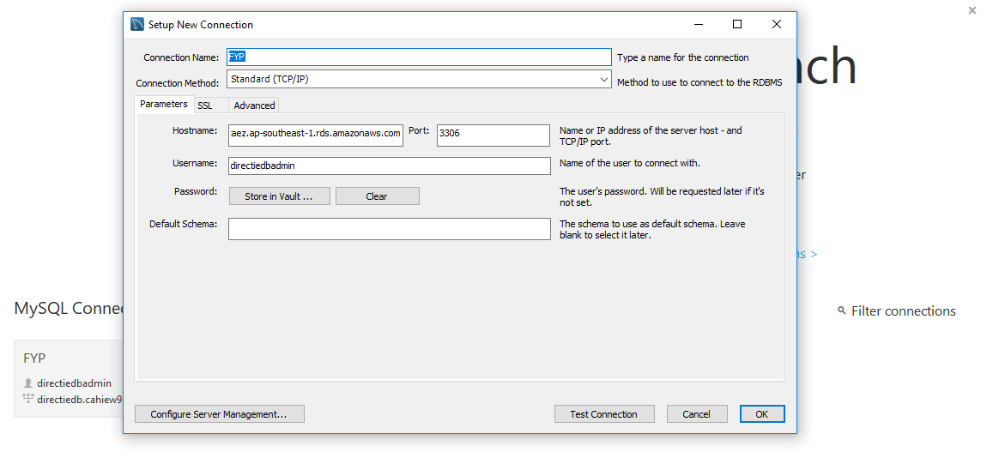

**Step 12 -** Download the sql file in this link : https://drive.google.com/open?id=1sZ5AwGbKKRIsilOdUPmEm8J6Y8L6oKBt

**Step 13 -** In your sql, click “Data Import/Restore” under “Management”

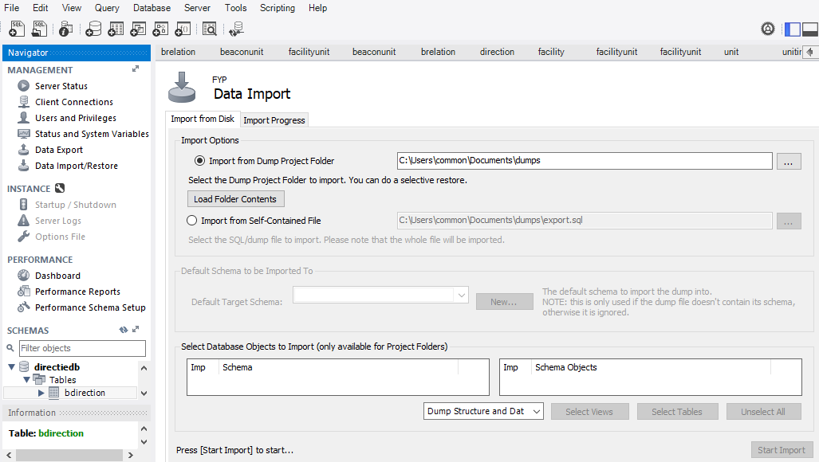

**Step 14 -** Select “Import from Self-Contained File” and choose the file downloaded in step 12 and click “Start Import” button

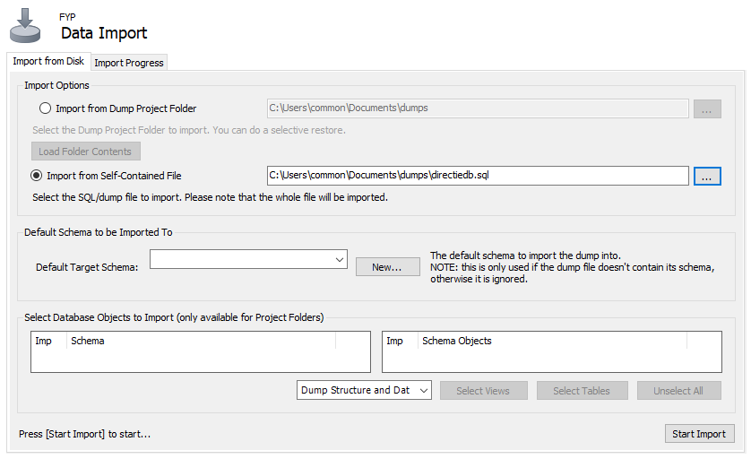

#### **1.1 Setting up AWS Lambda**

**Step 1 -** Click on Lambda under the “Compute” category or search “Lambda”

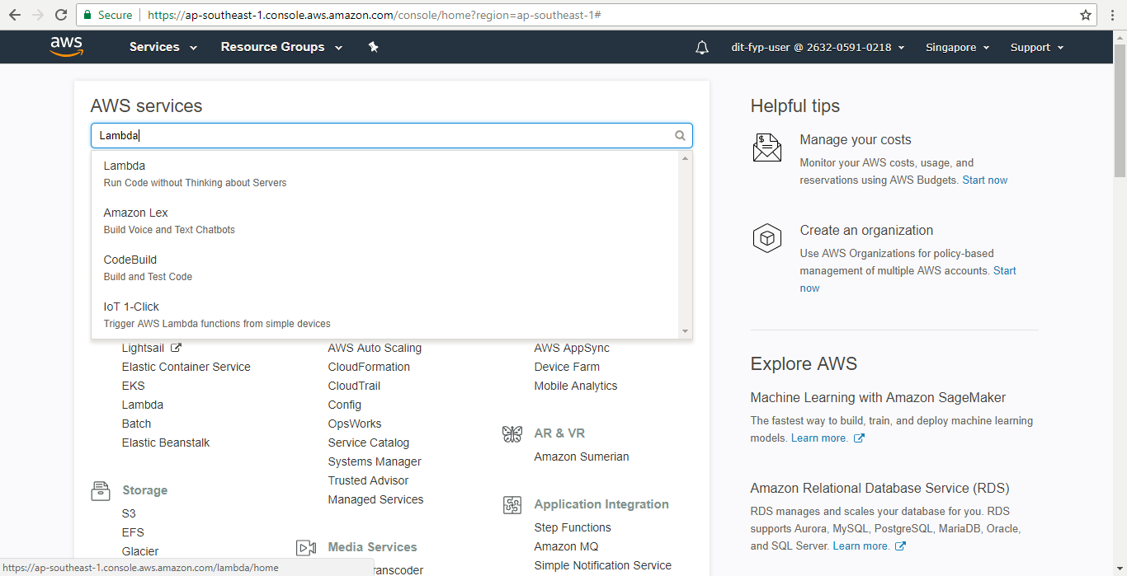

**Step 2 -** Click on “Create function” button

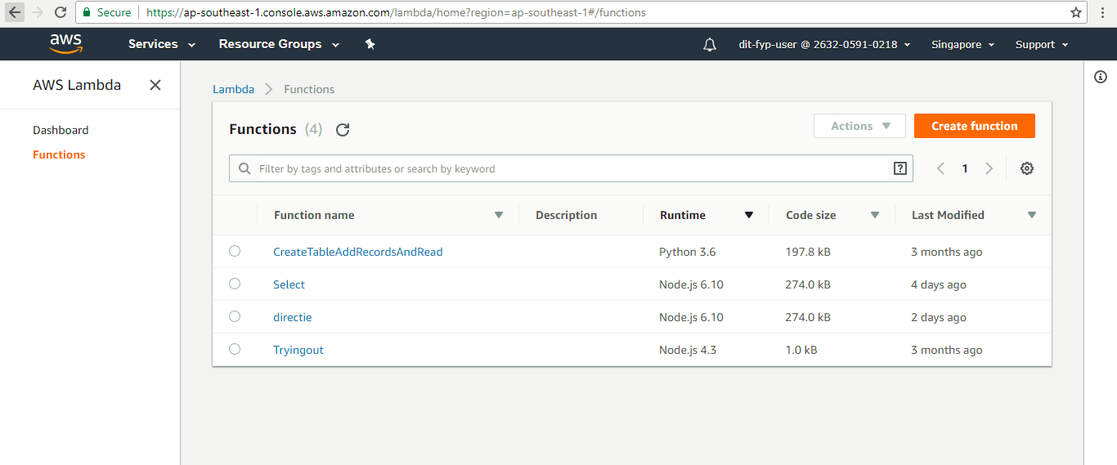

**Step 3 -** Select “Author from scratch” and enter your own Lambda function name. For runtime select “Node.js 6.10”. Create a new role or use an existing that allows full access to lambda.

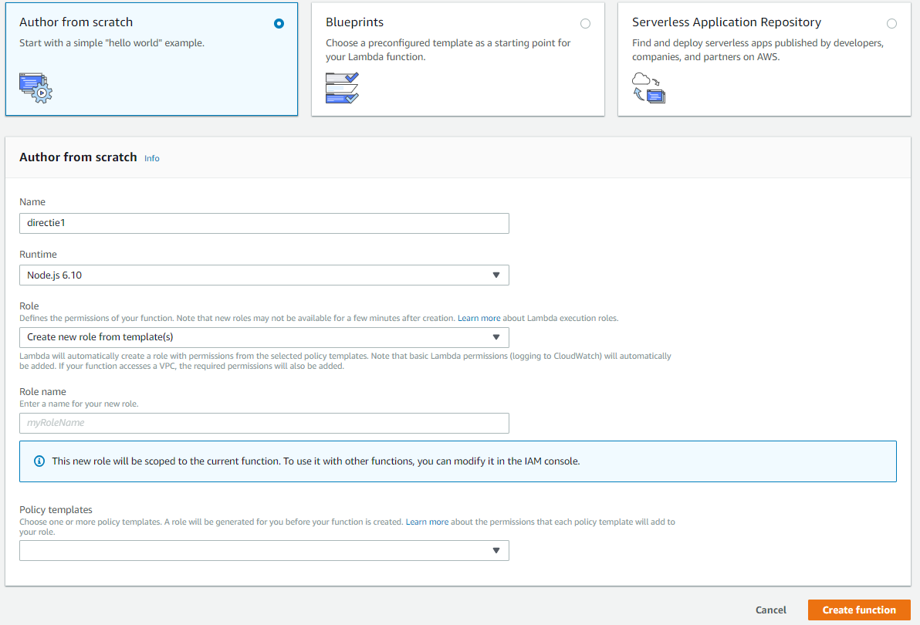

**Step 4 -** You should be redirected to your new Lambda function page.

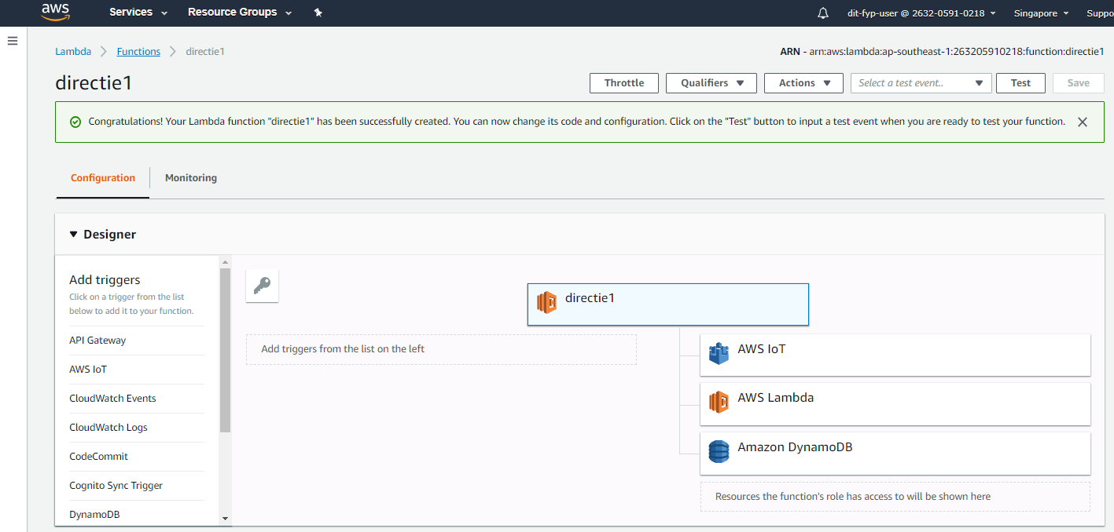

**Step 5 -** Scroll down to the “Function code”. Click on “Upload a .ZIP file” under “Code entry type”

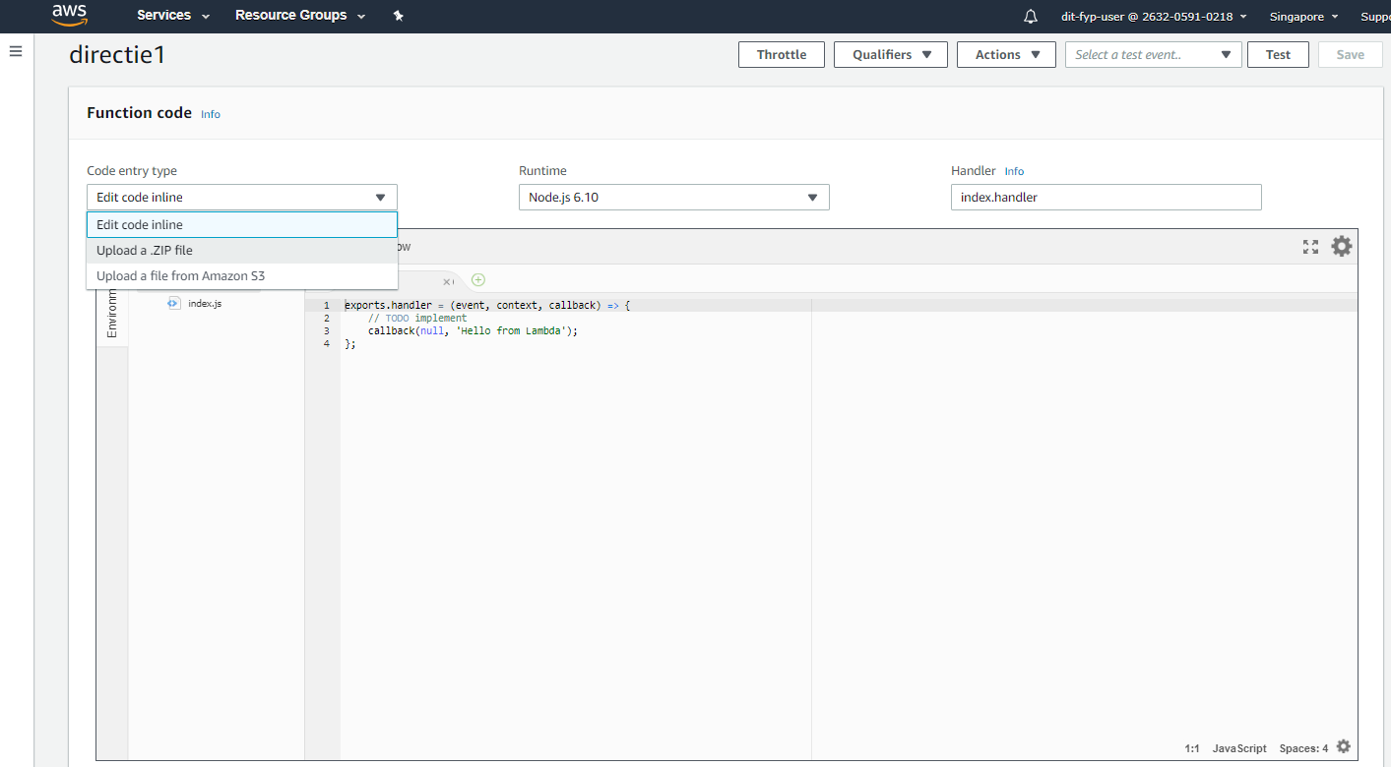

**Step 6 -** Download the .ZIP file in this link :https://drive.google.com/open?id=1gLdG_dkLwit0VO0uhbPFpuYv0frKIgTD

**Step 7 -** Change Handler to “directie.handler”. Click on “Upload” button and select the .ZIP file downloaded from Step 6.

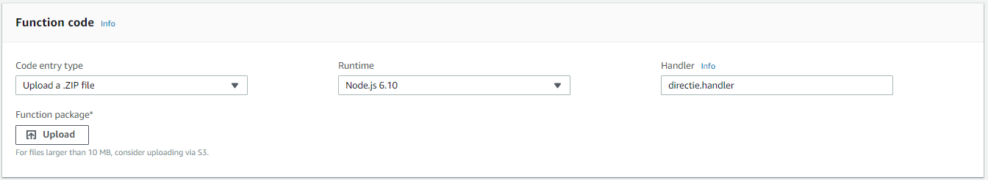

**Step 8 -** Click on the “Save” Button

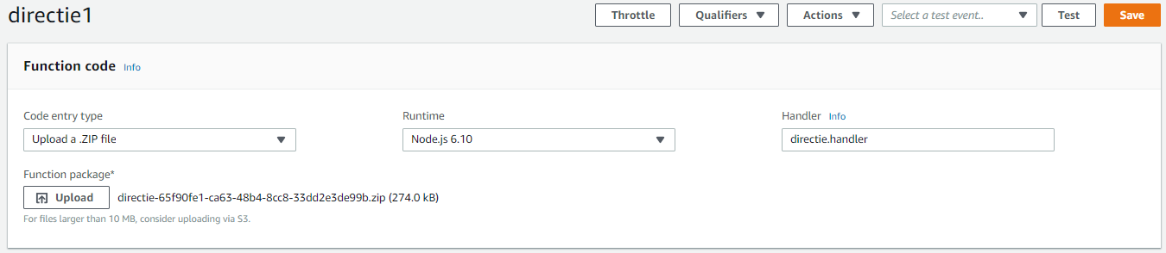

#### **1.2 Setting up AWS API Gateway**

**Step 1 -** Click on API Gateway under the “Networking & Content Delivery” category or search “API Gateway”

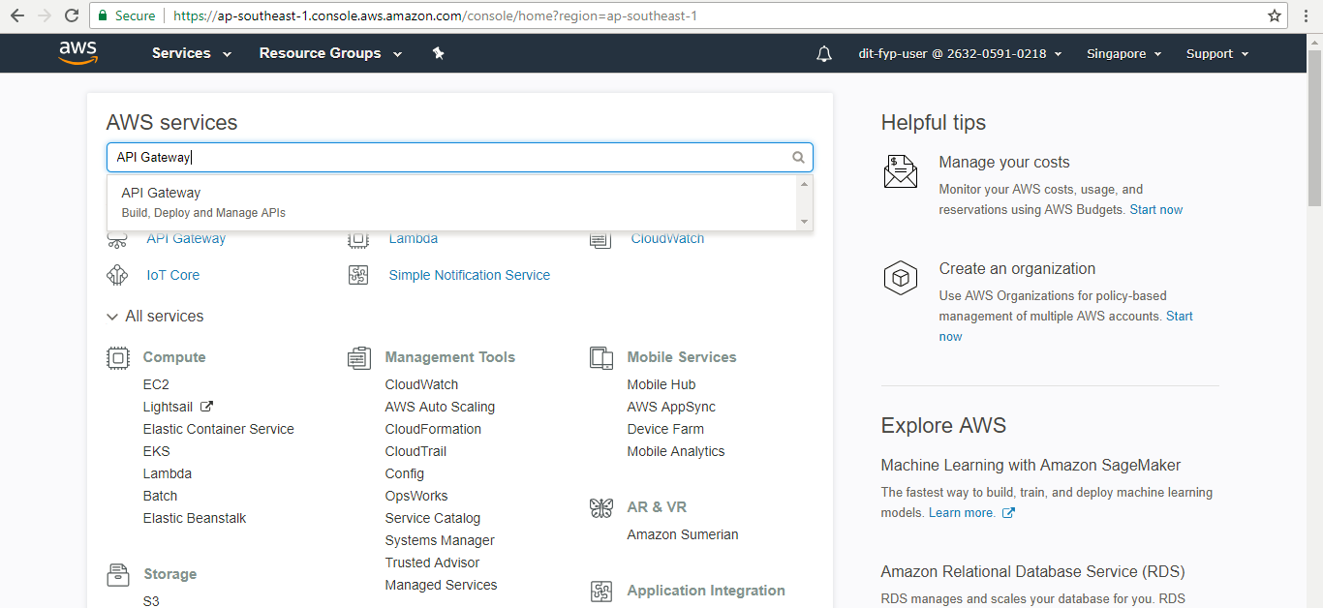

**Step 2 -** Click on “Create API”

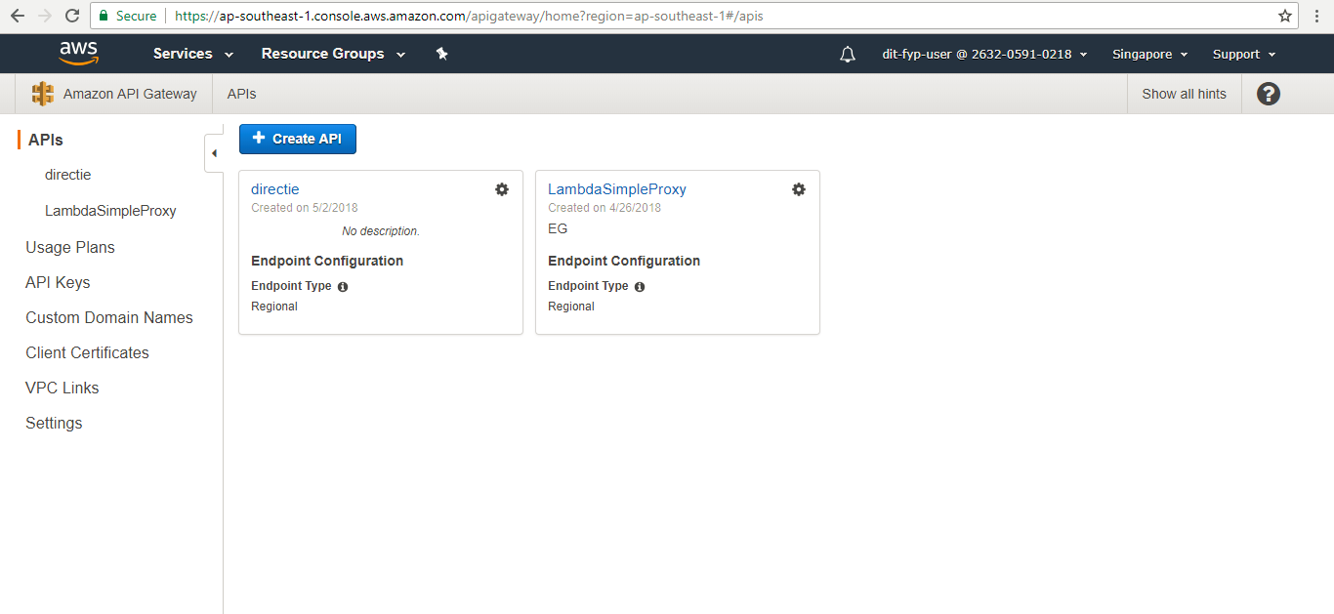

**Step 3 -** Enter your own API name and description and click “Create API”

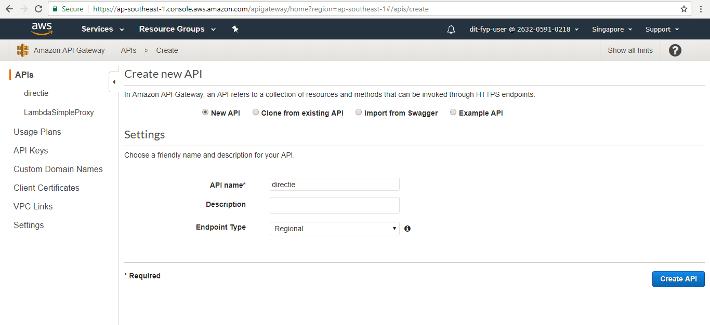

**Step 4 -** Download the text file in this link :

https://drive.google.com/open?id=13I7lrRuHFu68HK0dGiBTXgYWrhS_DvCZ

**Step 5 -** Click on “Models” on the left navigation bar and click “Create” button

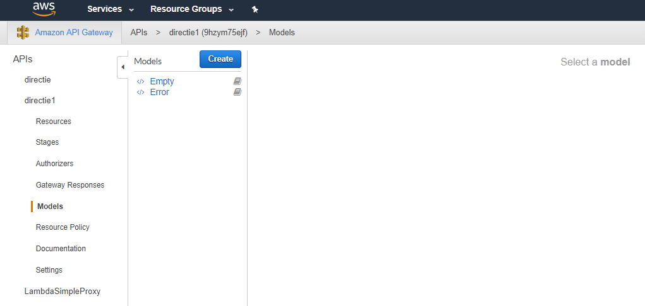

**Step 6 -** Enter your Model name and description. For content type enter “application/json”. Open the text file downloaded in step 4, copy and paste everything into the Model schema and click “Create Model” button. 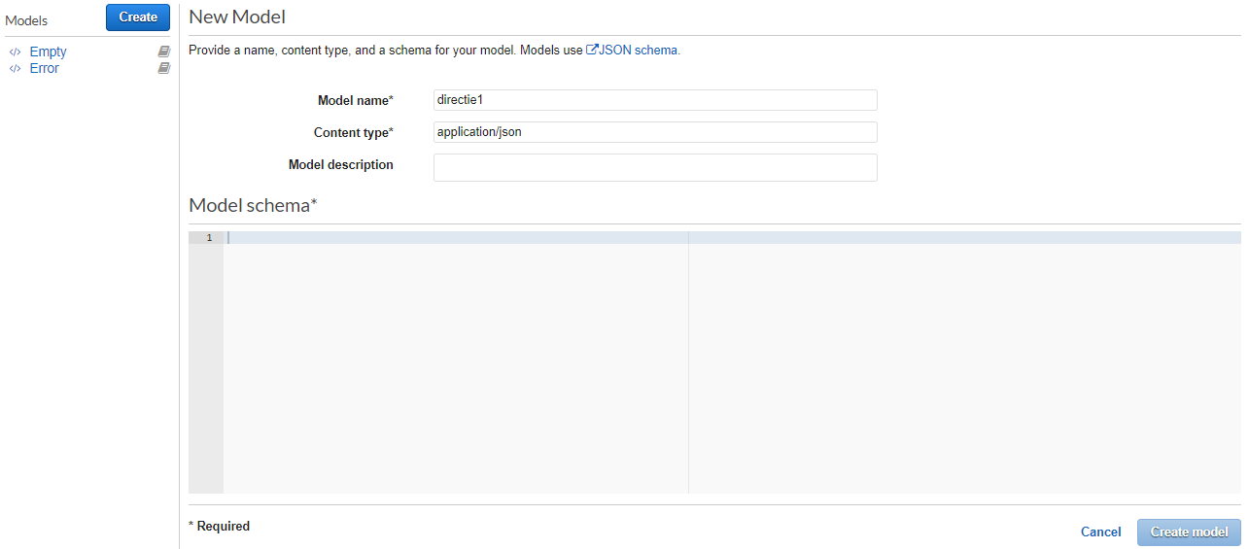

**Step 7 -** Go back to the Resources page and click “Create Method” under “Actions”

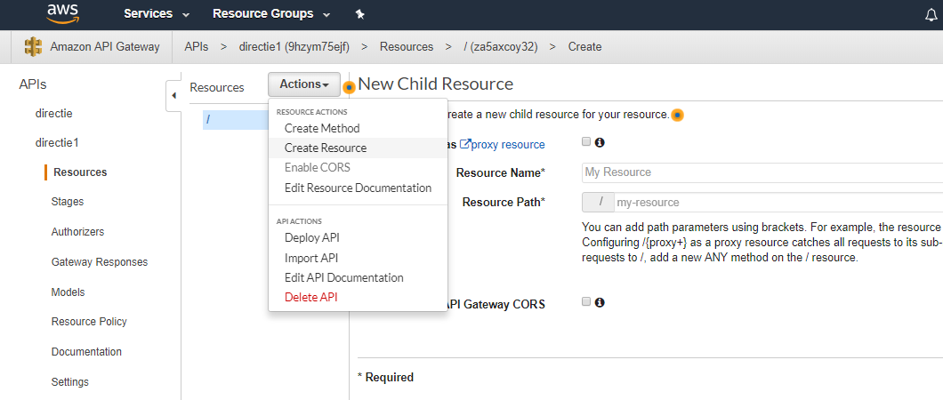

**Step 8 -** Follow the image below for the configurations of the new Resource and click “Create Resource” button

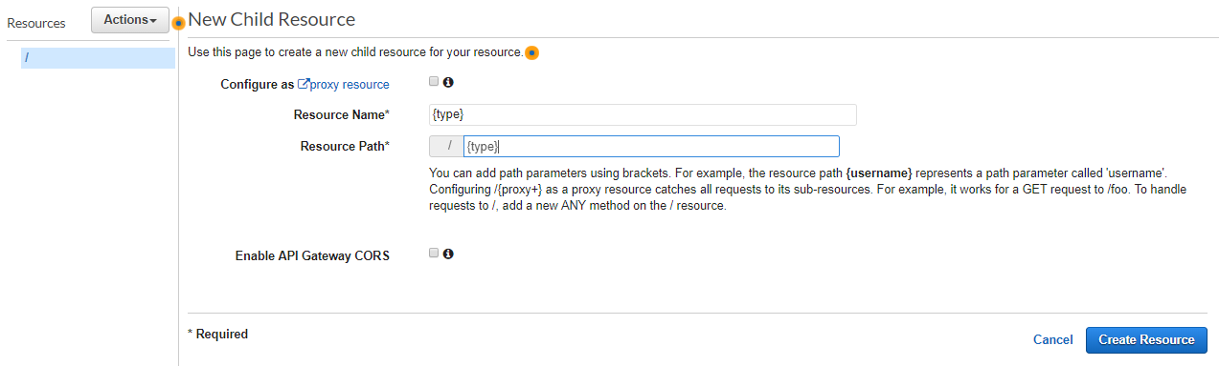

**Step 9 -** Under the {type} Resource, click on “Create Method” under “Actions”

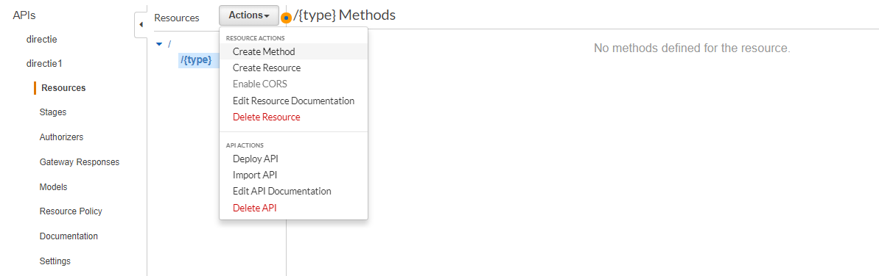

**Step 10 -** You can create GET, POST, PUT and DELETE methods with the same setup but we are going to only use POST method.

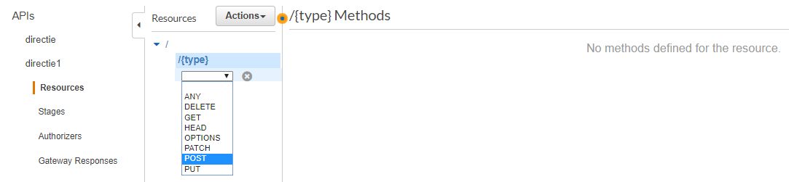

**Step 11 -** Follow the image below for the POST method Setup, enter the Lambda function name you created in Part 3.0 in this tutorial and click “Save” button 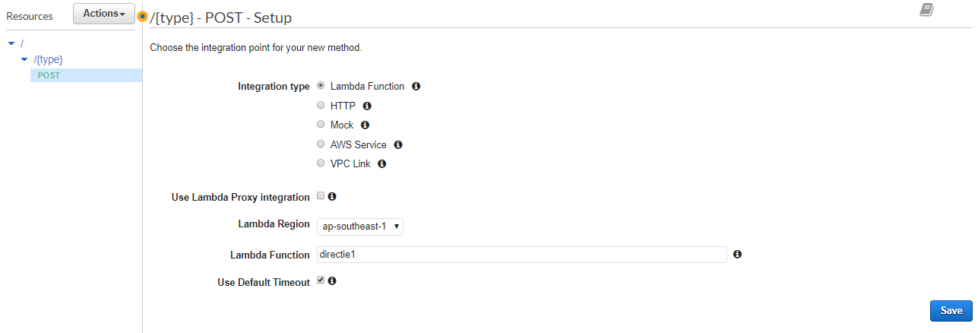

This will pop out after clicking “Save” button, click “OK”.

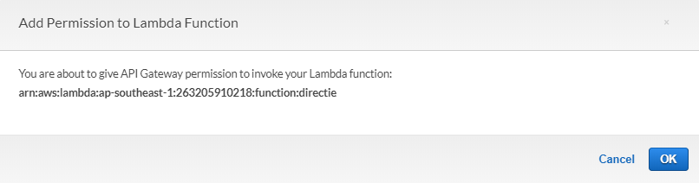

**Step 12 -** Click on “Method Request”

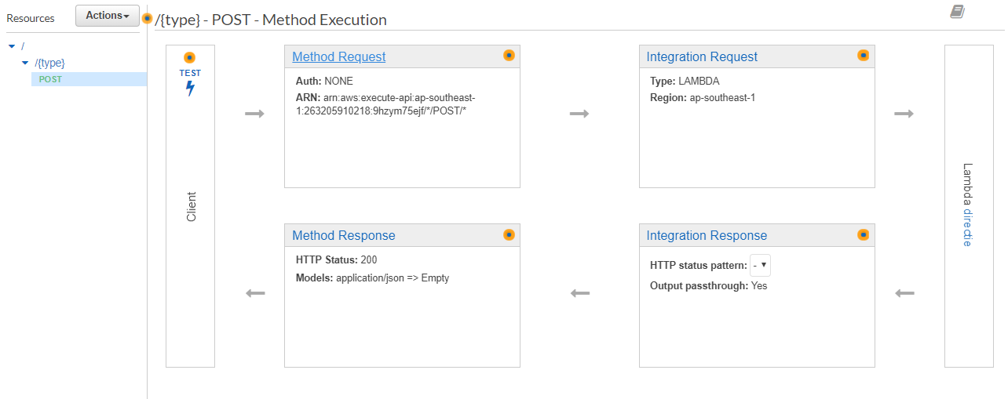

**Step 13 -** Follow the image below for Method Request. Under Request Body, enter Content type “application/json” and choose the Model created in step 6 and click “Method Execution”

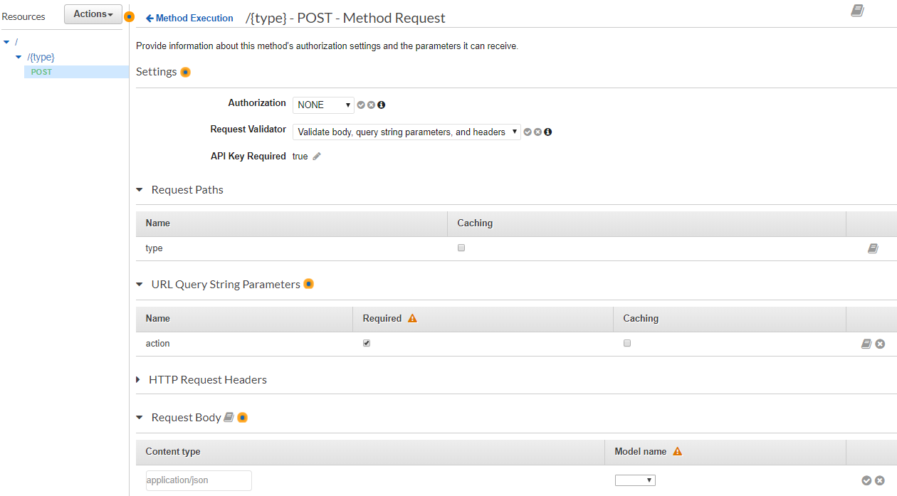

You can choose not to use the API Key, set it to “false” if you do not wish to do so.

**Step 14 -** Download the text file in this link :

https://drive.google.com/open?id=15L_7briG45qa12sgUGSpmOiuZVfajLHJ

**Step 15 -** Click on “Integration Request”

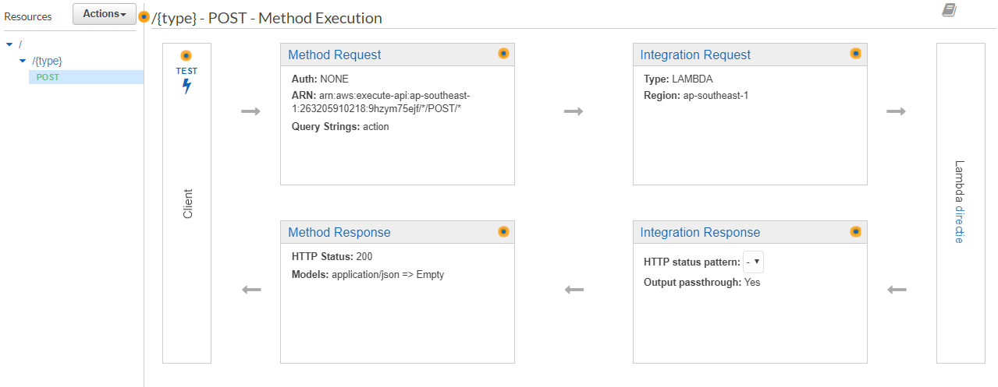

**Step 16 -** Follow the image below for Mapping Templates in Integration Request, open the text file downloaded in step 14, copy and paste everything into the Mapping Template, click “Save” button and click “Method execution”

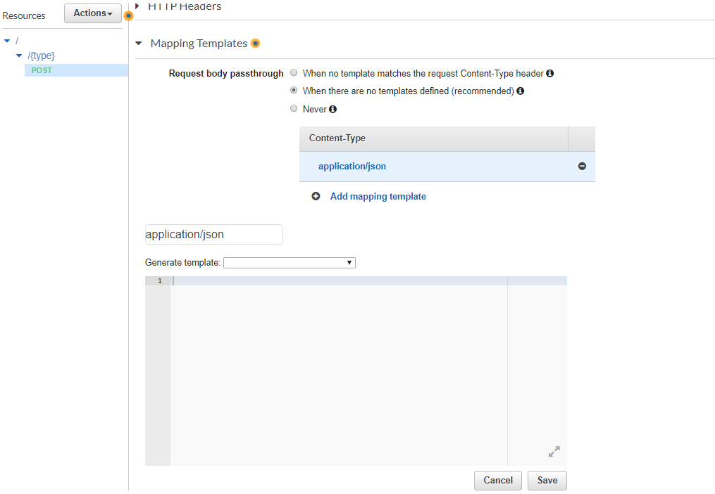

**Step 17 -** Click on “Enable CORS” under “Actions” and click “Enable CORS and replace existing CORS headers” button

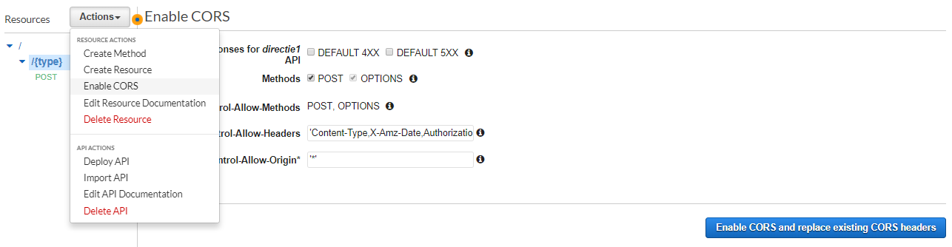

This will pop out after clicking “Enable CORS and replace existing CORS headers” button, click “Yes, replace existing values”.

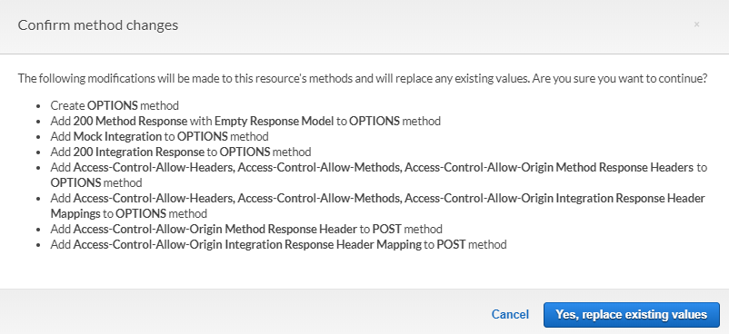

**Step 18 -** Click on “Deploy API” under “Actions”

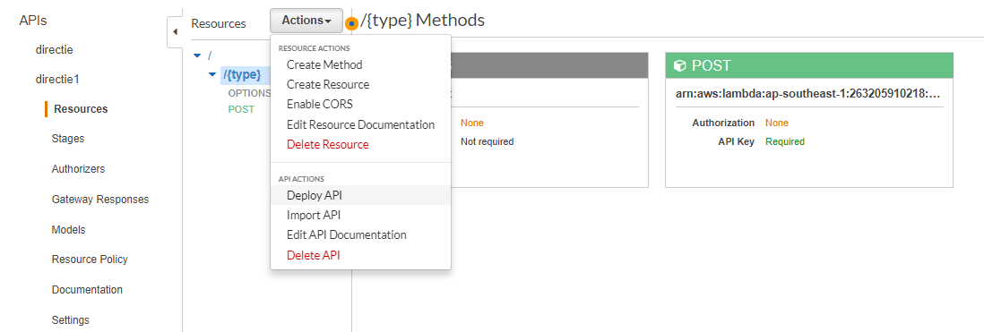

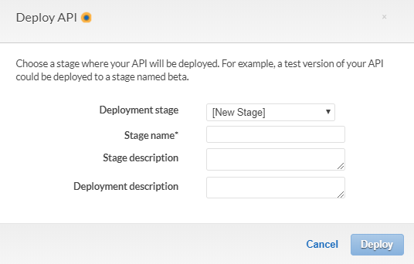

Enter your Stage name and descriptions for the API and click “Deploy” button

**\*If you chose to use API Key in step 13, continue with the tutorial below.**

**Step 19 -** Go to Usage Plans and click “Create” button, enter your plan name and description and follow the image below for other configurations and click “Next”

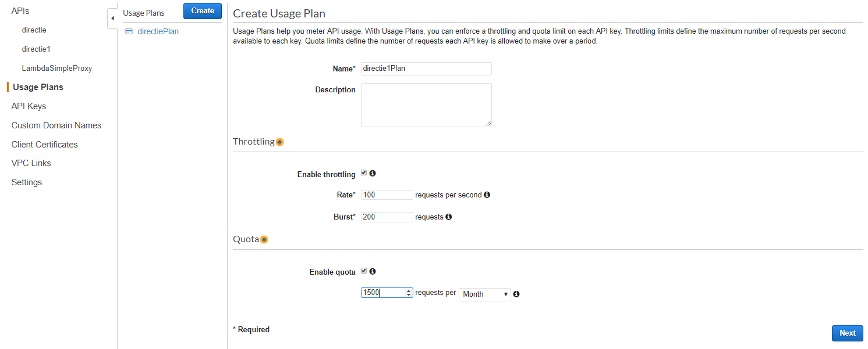

**Step 20 -** Add API Stage to the one in Step 18 and click “Next” button

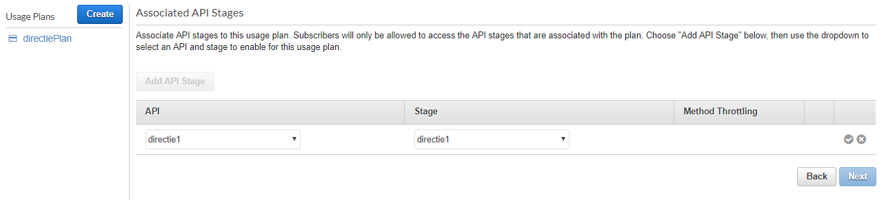

**Step 21 -** Add an API Key to the Usage Plan and click “Done” button

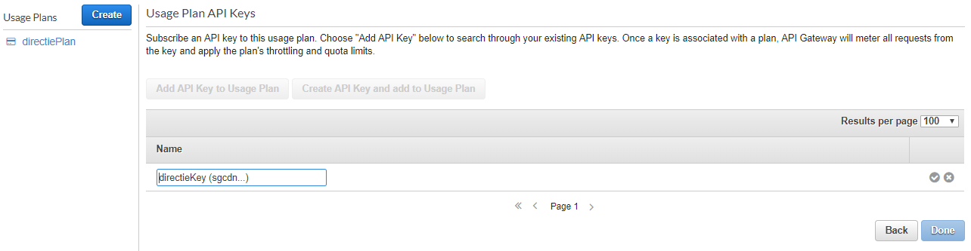

You can create an API Key by going to the “API Keys” in the left navigation bar and click “Create API key” under “Actions”

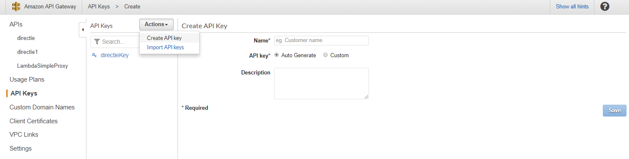

#### 

#### **1.3 Integrating AWS API into Front-End/Back-End**

**Front-End**

**Step 1 -** Make sure to use Ionic 3 and update all @angular dependencies, then edit and import the HttpClientModule into the app.module.ts

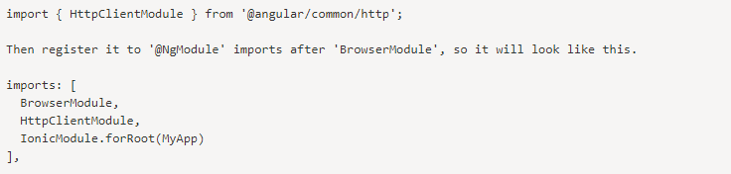

**Step 2 -** Create a provider and follow the code below which shows an example of API call to get BRelation



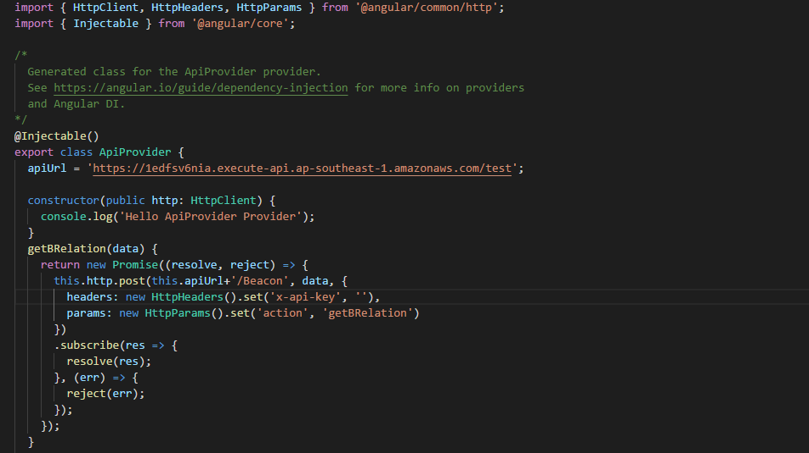

The apiUrl is the one in the API stage and make sure you put your api key if you use one in the headers.

**You can then call this api provider to get data**

**Back-End**

**Step 1 -** Go to the SDK Generation in API stage and select “Javascript” for platform and generate the SDK

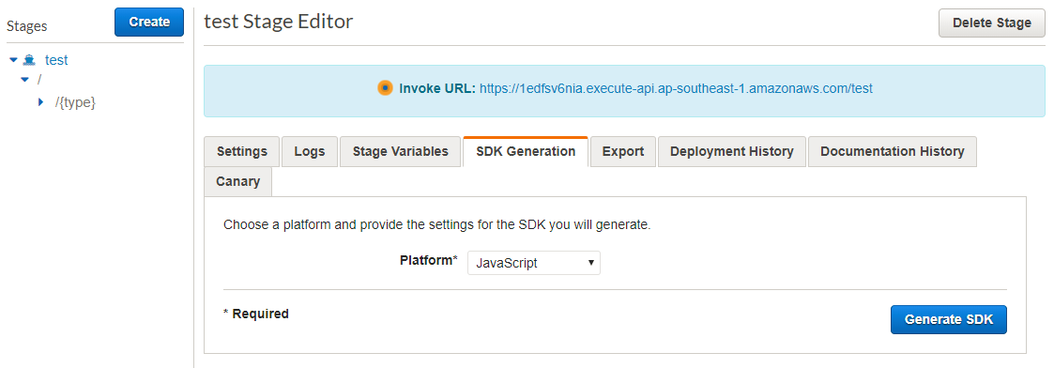

**Step 2 -** Extract and place the file in the back-end project folder and include these references to a script

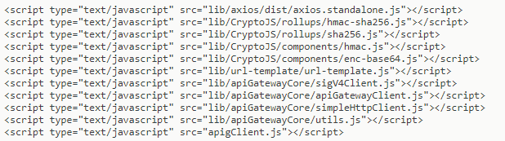

**Step 3 -** Place the following code below to initialize the SDK



**Step 4 -** You can then follow the code format below to call the API method you want.

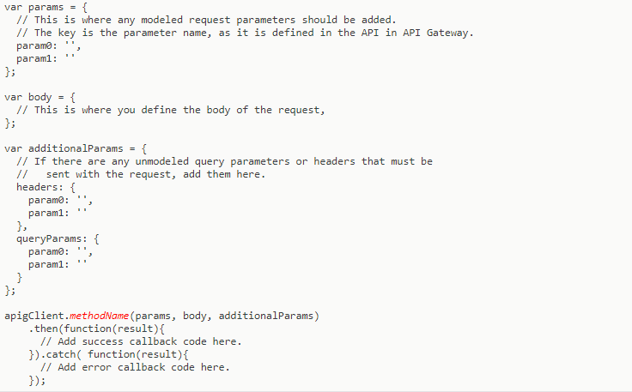

If you are using API Key your additionalParams should look like this.

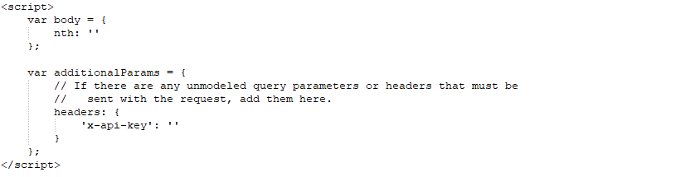

An example of the params and body when calling the api to get a FacilityUnit by ID. Go to our API Documentation to know more about the API call.





### 

### 

### **2.0 Setting up Firebase**

Before setting up Firebase, you must sign up for a Google Account if you do not have one.

**Step 1 -** Go to <https://console.firebase.google.com/> and click on Add project under Recent projects.

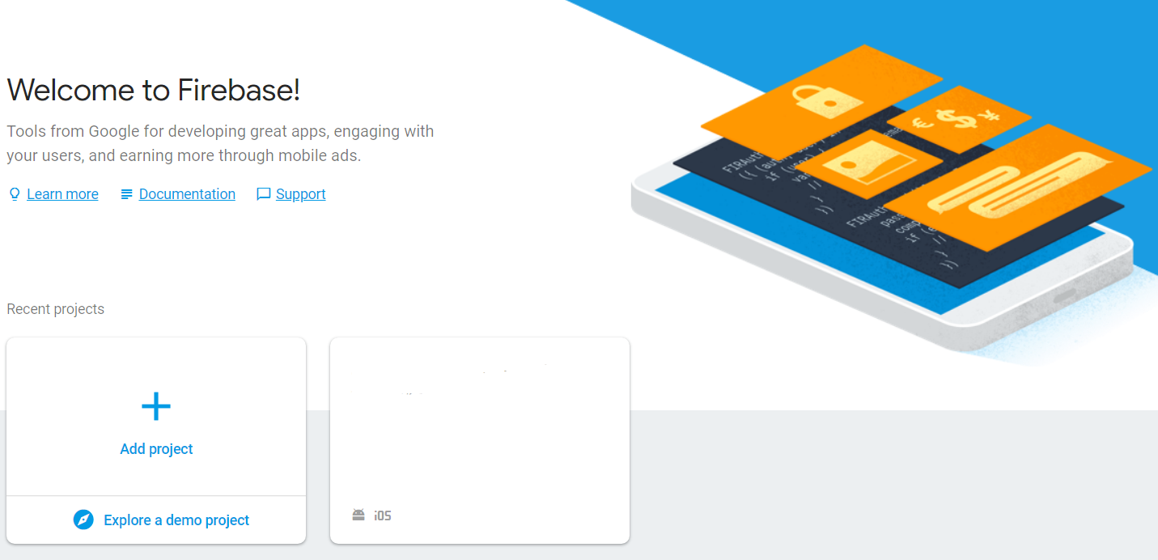

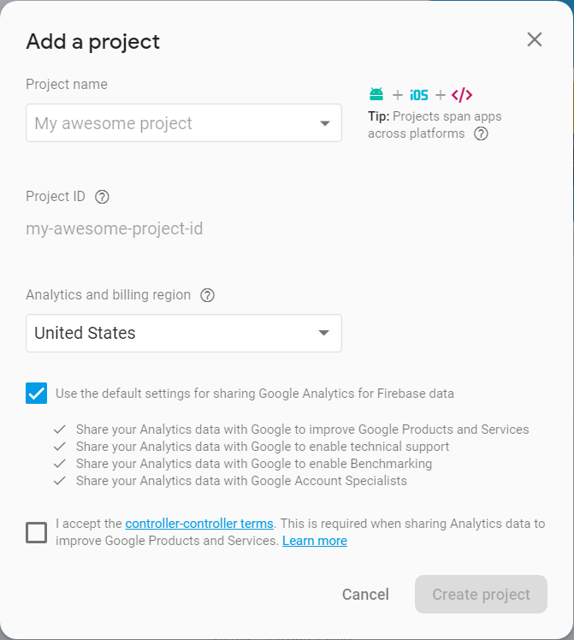

**Step 2 -**

Give the project a name, for example, “FYP-PWA”. Tick the last checkbox and click on ‘Create project’.

When it shows ‘Your new project is ready’, click on the Continue button.

#### **2.1 Setting up Firebase Authentication**

**Step 1 -** After creating your first project, click on Authentication on the menu. You will see a screen like this.

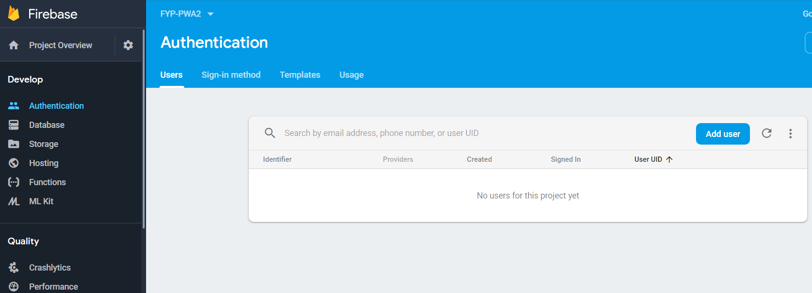

**Step 2 -** Click on the Sign-in method tab and enable 3 providers: Email/Password, Google and Facebook.

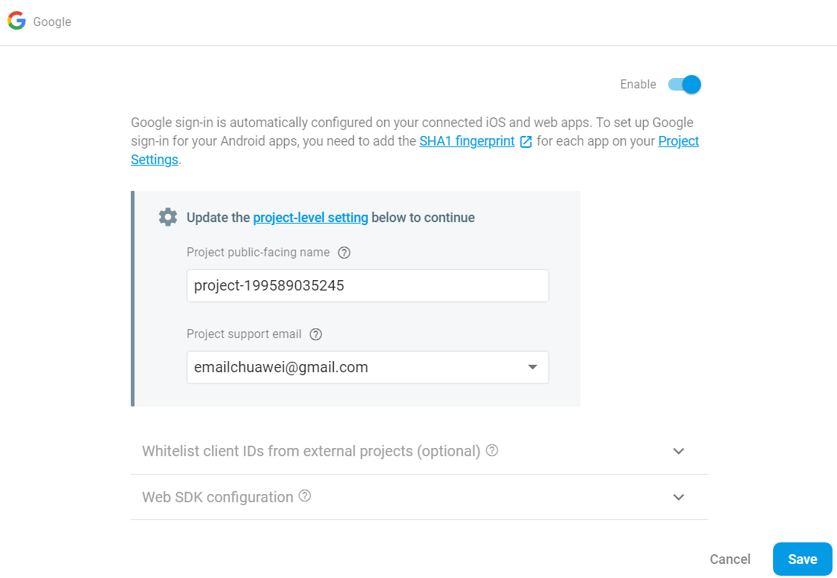

**Step 3 -** For Google, update the Project support email as the email that you have create for this project.

**Step 4 -** For Facebook, if you already have an existing App ID and Secret, you may use it and add the OAuth redirect URI to the Facebook app configuration.

**Step 4.1 -** If you do not have a existing App ID and Secret, you need to create a Developer Account here: <https://developers.facebook.com/docs/apps/register/> (You need to have a Facebook Account first before creating a Developer Account). After signing in, click on Create a Developer Account.

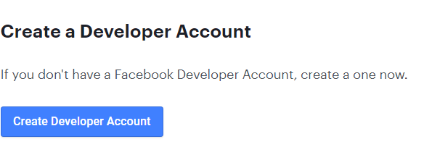

**Step 4.2 -** A pop-up will appear. Click on next and you may choose to edit the App Name or Contact Email if you want.

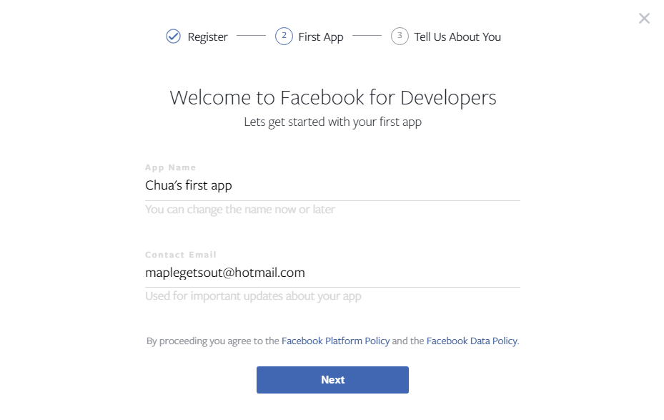

**Step 4.3** - Click on Developer and after creating an account, click on Add Your First Product. Then, click on Set Up under Facebook Login

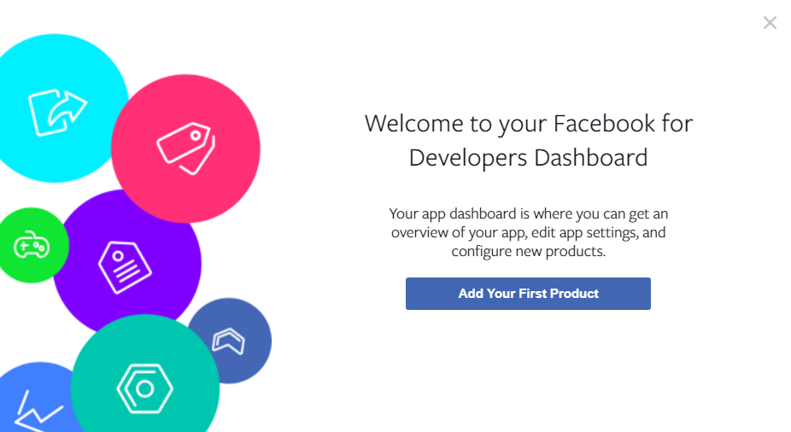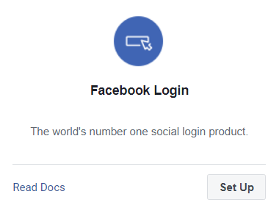

**Step 4.4** - After being redirected to a page, click on Settings under the Products Section. Insert the OAuth Redirect URI from Firebase to the Facebook’s Valid OAuth Redirect URIs.

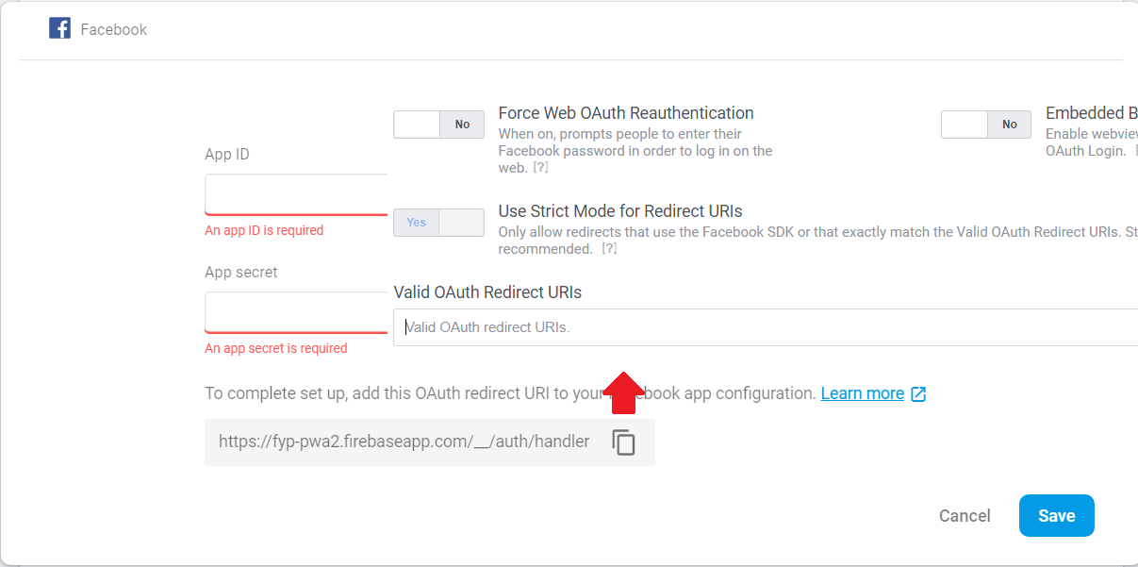

**Step 4.5** - To retrieve the App ID and App secret, navigate to Settings under the menu in the Facebook Developer page, click on show and copy them to Firebase.

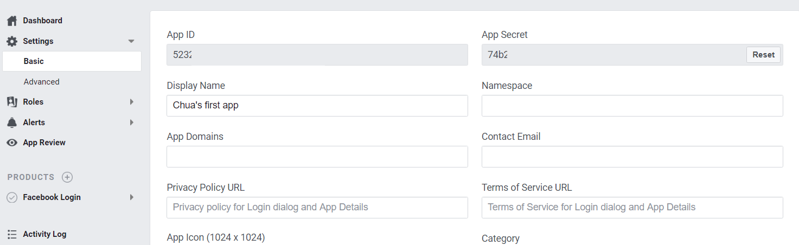

**Step 5** - Click on Save once completed. You will now have 3 enabled providers for Authentication.

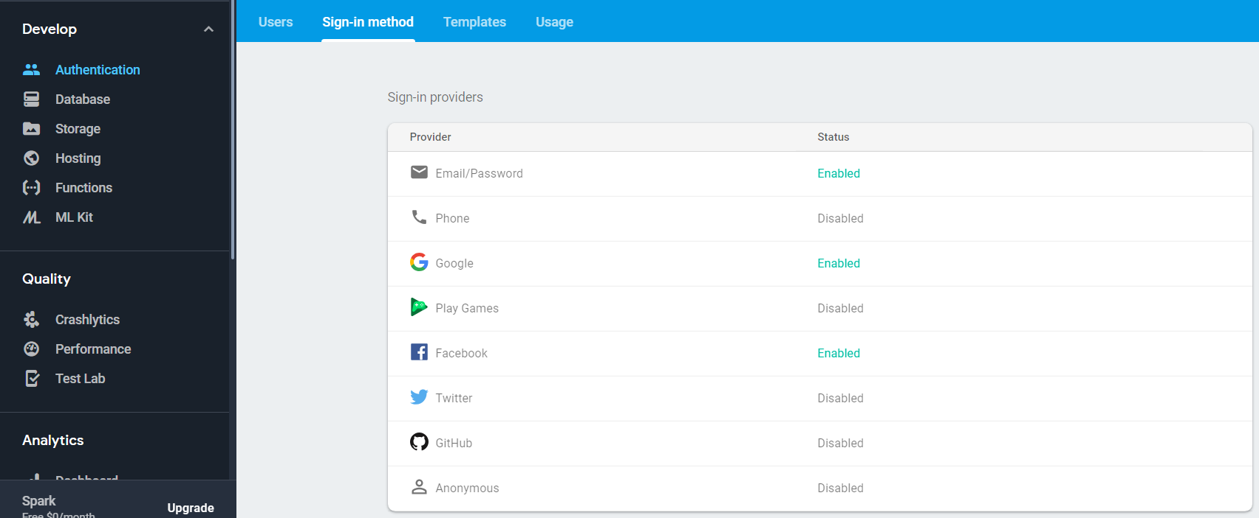

#### 

#### **2.2 Setting up Firebase Database**

**Step 1** - Click on Database on the menu and scroll down to ‘Or choose Realtime Database’. Click on create database and a pop-up will be shown.

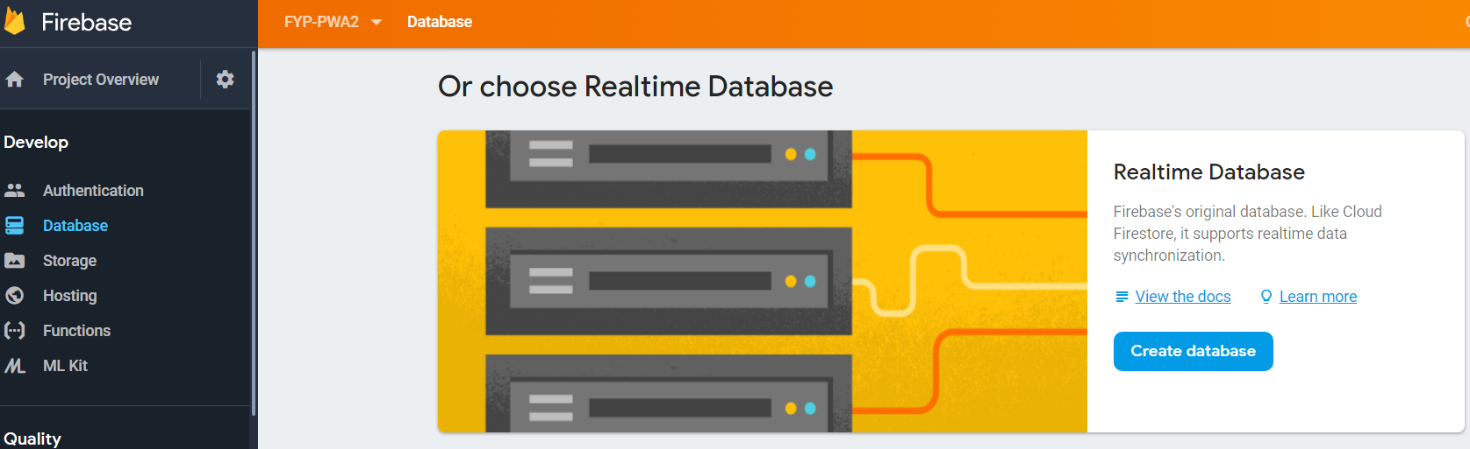

**Step 2** - Click on Enable.

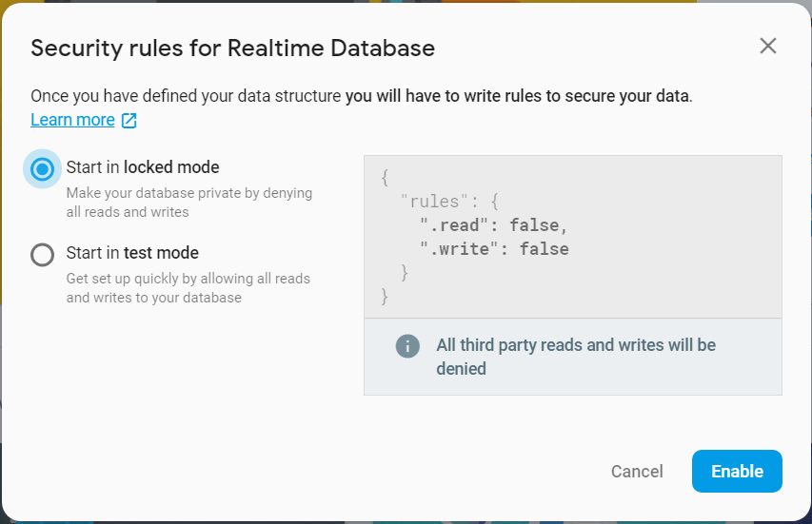

**Step 3** - On the right side, click the more button (beside the + and - icon) and click on import JSON. Upload the file ‘pwa-firebase-hosting-export-final.json’ and click on Import.

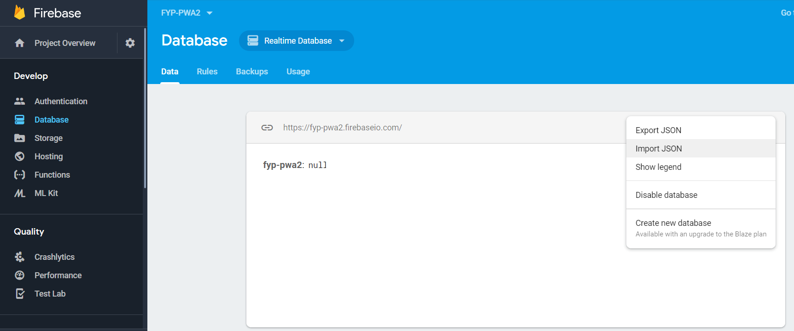

**Step 4** - You should see something like this once you have imported successfully. Although you cannot see the structure of the database, you can see it once a route has been completed/failed, or when a user has been created.

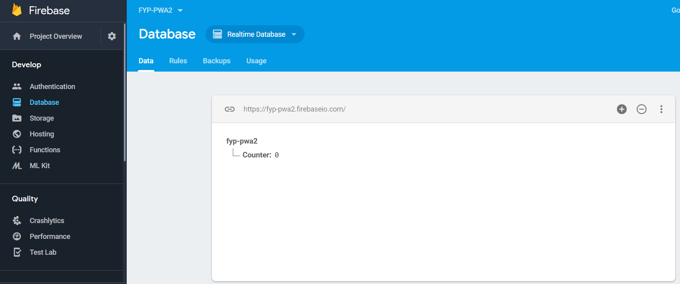

### 

#### **2.3 Setting up Firebase Storage**

**Step 1** - Navigate to Storage under the menu and click on ‘Get Started’.

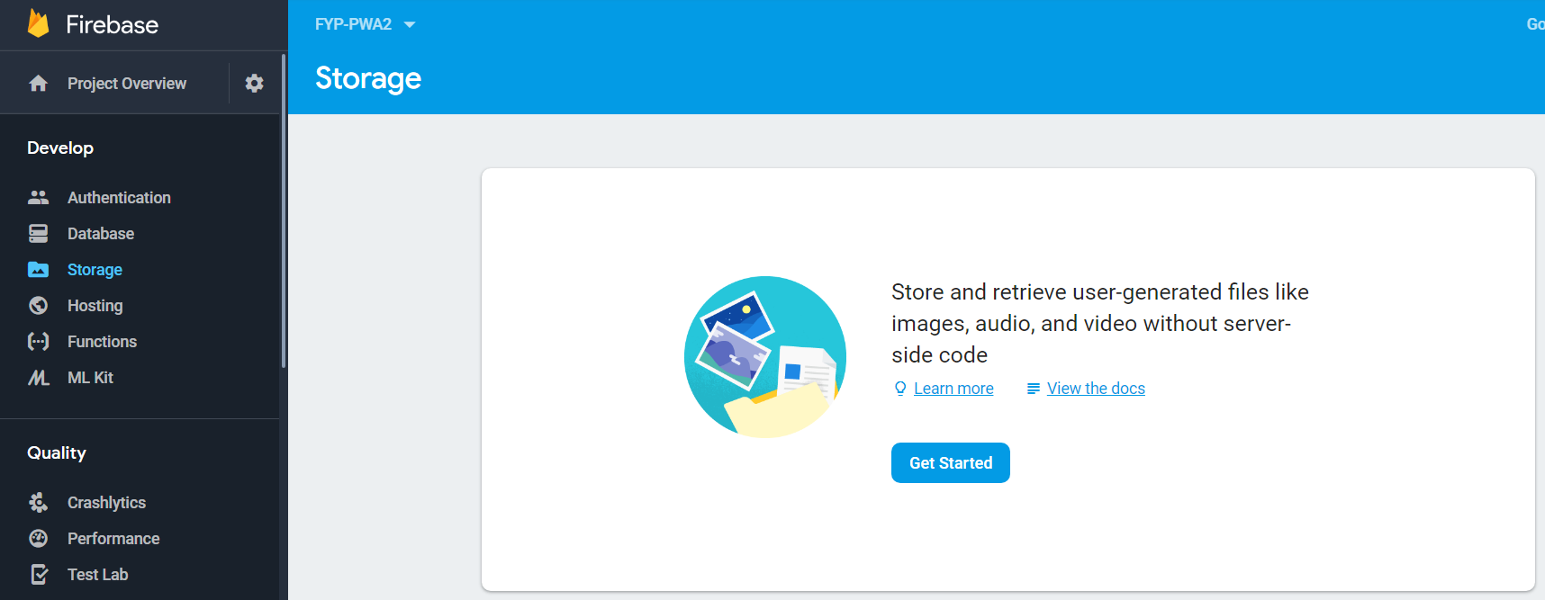

**Step 2** - A pop-up will appear. Click on ‘Got it’.

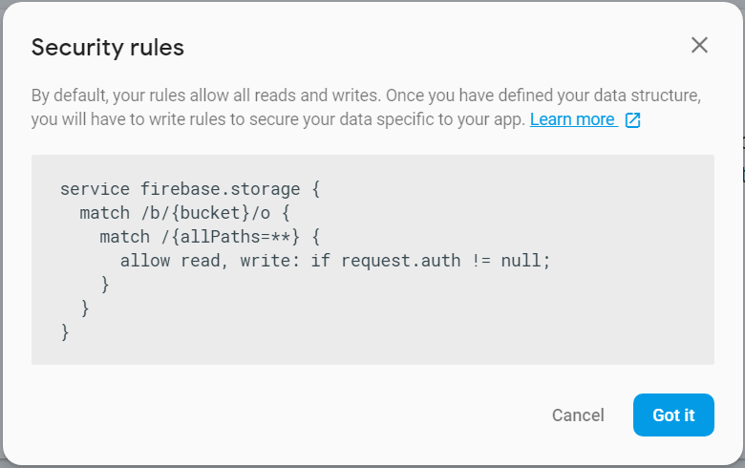

**Step 3** - On the top right, click on the add folder icon

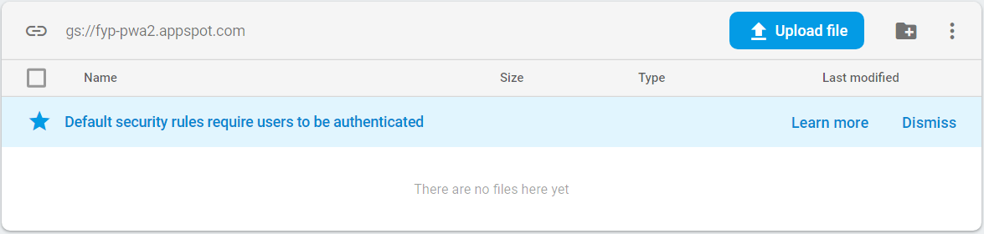

**Step 4** - Make a directory something like this:

images/

images/facilities/

images/ProfilePicture/

images/units/

Your root folder will have something like this:

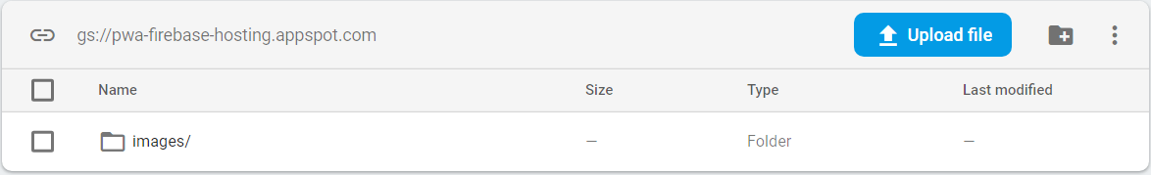

From there, the Firebase Storage is completed!

### 

#### **2.4 Setting up Firebase Hosting**

Before you proceed, make sure you have Node.js installed on your computer. If you do not have one, you can download from here: <https://nodejs.org/en/>.

**Step 1** - Once you have Node.js installed, you will need to install the Firebase CLI Reference. The CLI Reference helps you to deploy your project to Firebase Hosting. Open up command prompt, type ‘npm install -g firebase-tools’ and enter.

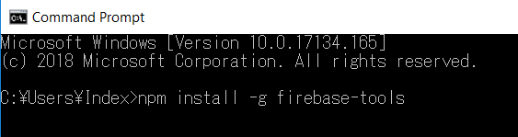

**Step 2** - After a few seconds(or later), you will see something like this. This means that you have successfully installed. Login to firebase via this command ‘firebase login’. Enter your firebase credentials.

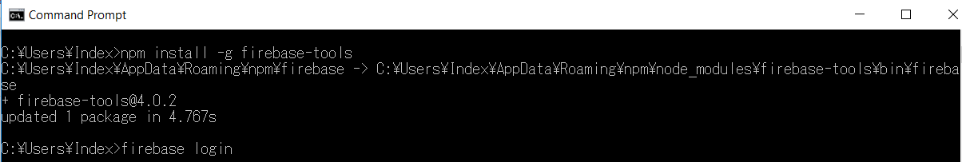

**Step 3** - Once you have logged in, it means that you are connected to your account. Change your directory to a folder where you can setup the deployment with this command: ‘cd <your_directory_here>’. After changing your directory, it is time to create your firebase hosting folder. Type ‘firebase init’ and press enter.

**Step 4** - Type ‘Y’ and press the Enter to confirm your directory. Then, select the features Functions and Hosting by navigating using up and down arrow keys, space to select features and Enter to confirm your choice.

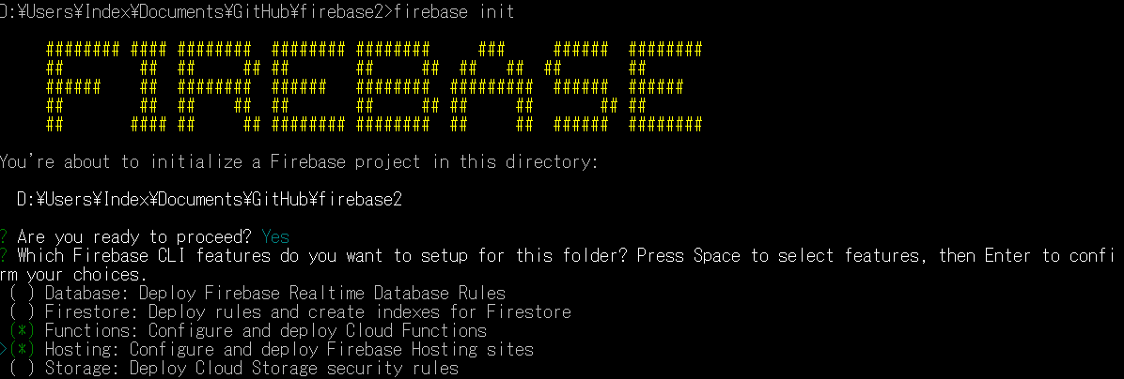

**Step 5** - After that, select the project that you are going to use, then press Enter twice. If you were given a choice to use ESLint or install the dependencies with npm, type ‘n’ and press Enter. Type enter again and if you are asked to configure as a single page-app, type ‘n’ and press Enter. From there, you have successfully created a folder!

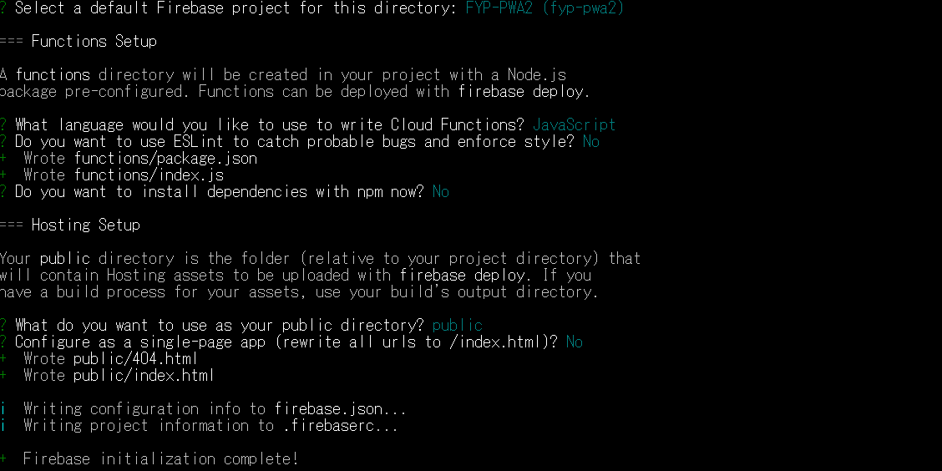

**Step 6** - Now, it is time to insert the files to your Firebase project. Unzip the backendsetup.zip and overwrite the files and folders on your project directory.

**Step 7** - Before you start to deploy, delete the file at public/index.html. This file prevents you from entering any website that is hosted by the Node.js’s Server API.

**Step 8** - When you are done, use your command prompt and type in ‘cd functions’. You will be directed to the functions folder. Type in ‘npm install’ and press enter. This will download and install all the plugins that are integrated in this project. You will get something like this after installation.

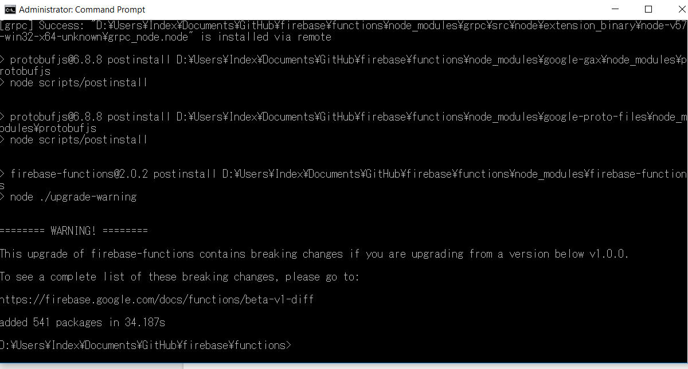

**Step 9** -

Finally, you are now able to deploy your own firebase website!

To host on your website locally, type ‘firebase serve’ and press enter.

To host on your website on the firebase server, type ‘firebase deploy’ and press enter. Take note that hosting on the firebase server may take some time.

Once deployed on the firebase server, you should see something like this. Use the link given to access your website. You **should not deploy until you finish integrating the back-end site**.

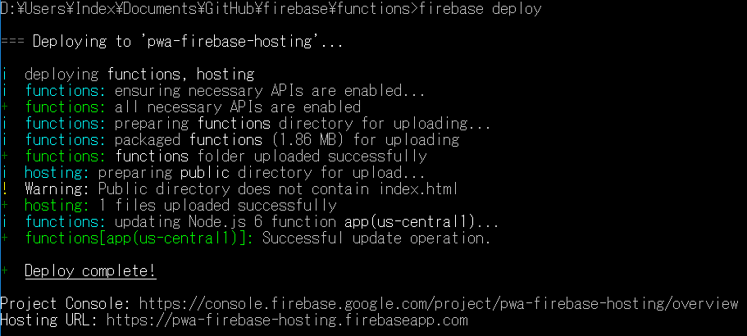

#### **2.5 Integrating Firebase into Front-End/Back-End**

In order to integrate your Firebase Authentication, Database and Storage to your Web and Mobile Application, you require some keys in order to access them. In this setup, we will show you how to get your configure keys and where to insert them in both mobile and web application.

**Step 1** - First, go to <https://console.firebase.google.com/> and select the project that you have created on Step 2.0. From there, click on Project Overview located at the top left on the menu. You will see something like this:

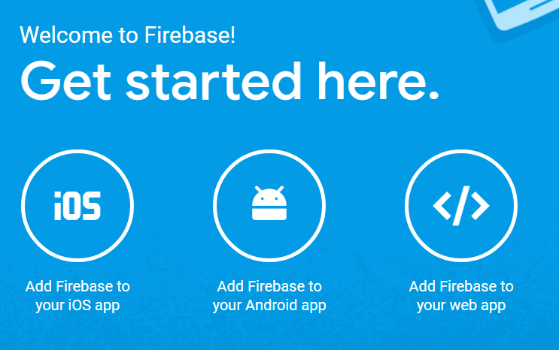

**Step 2** - Click on web app, and a code will appear something like this below. This is your configure key and you will need it for both front-end and back-end. Do not close this tab, or you can also copy the config into a notepad.

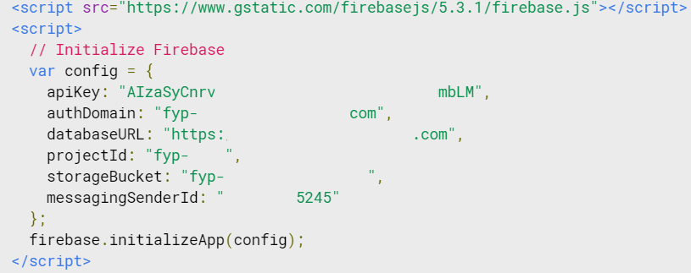

**Step 3** - Now, you need to create another key for back-end to retrieve the information from database. Go to the page <https://console.cloud.google.com/iam-admin/serviceaccounts/> and select your project on the top menu. You will see something like this once you have selected.

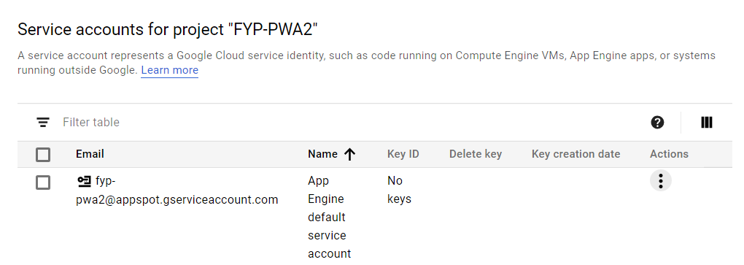

**Step 4** - Under “Actions”, click on Create Key and press Create. A .json file will be downloaded to your computer.

Next, we need to modify them on both front-end and back-end.

**Front-End**

**Step 5** - On the front-end folder, navigate to Directie/src/app/ and open app.component.ts on a editor (such as a Notepad). Search for ‘firebase.initializeApp’ and then replace the config with the ones you have on Step 2.

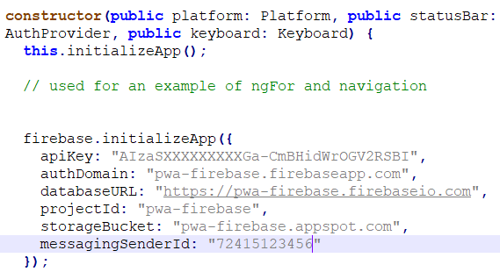

**Back-End**

**Step 6.1** - On the back-end folder, navigate to functions/ and paste the json file that you have just downloaded. Open index.js on a editor and search for ‘var firebaseConfig’. Replace the config with the ones you have on Step 2.

**Step 6.2** - Below the config, you should see another configuration for firebase-admin. Rename the serviceAccount to the file name that you have just downloaded. After that, copy the databaseURL and storageBucket from the firebaseConfig.

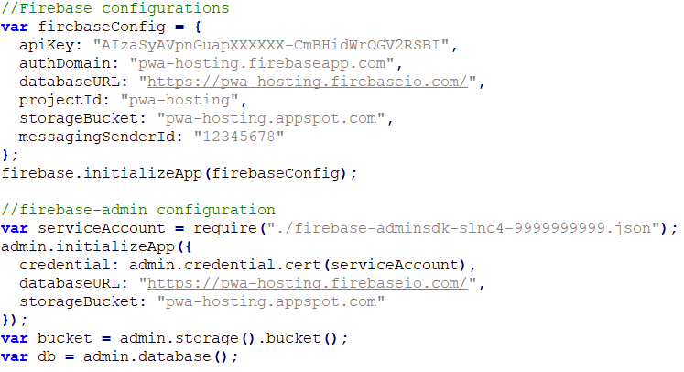

You are now ready to deploy your application!

### **3.0 Setting up Beacon Direction (Bearings)**

The administrator will have to set up the bearings associated with each beacon direction when implementing the system.

**Step 1:**

Place all the beacons at where you would want them in the indoor environment.

**Step 2:**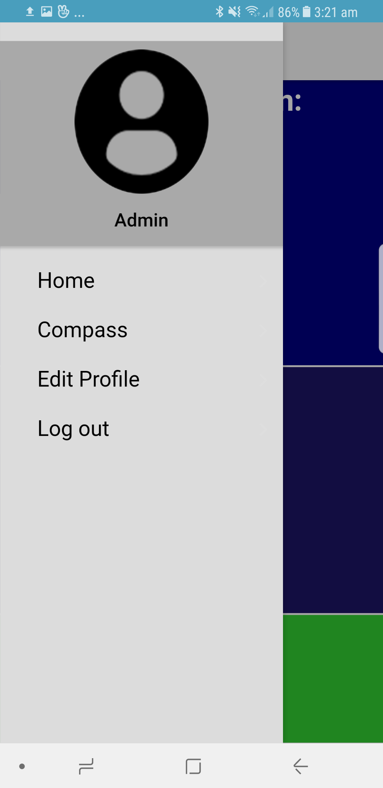

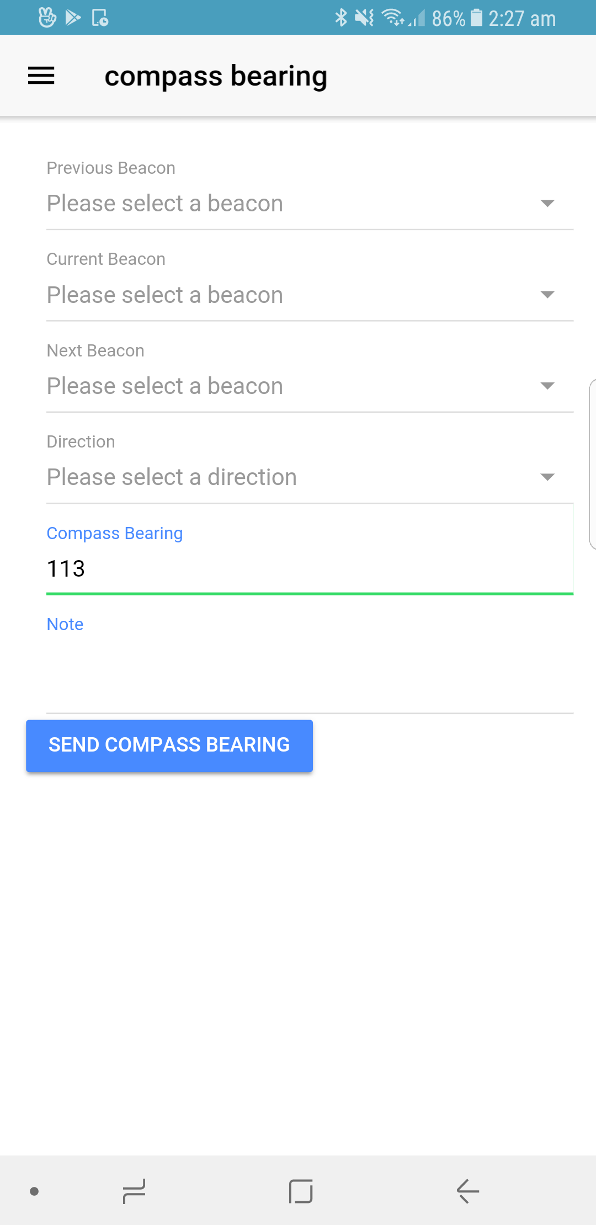

Using the Directie mobile application, login using an administrator account.

In the side menu, tap on **“Compass”**.

**Step 3:**

Stand beside one of the beacon.

**Step 4:**

For **“Previous Beacon”**, choose the beacon ID of the previous beacon to which you are standing beside.

**Step 5:**

For **“Current Beacon”**, choose the beacon ID of the beacon which you are standing beside.

**Step 6:**

For **“Next Beacon”**, choose the beacon ID of the next beacon to which you are standing beside.

**Step 7:**

Choose a direction for the path you want to set up in relation to the 3 beacons you have just selected.

**Step 8:**

When standing beside your “Current Beacon”, point your phone towards the direction of the “Next Beacon” that you have selected. The compass bearing will increase/decrease accordingly.

**Step 9 (Optional):**

If there is anything you want the user to take note of during his/her journey, enter a note under the “Note” field. What you enter will be read out along with the instructions when the user is about to reach that beacon.

**Step 10:**

Once you are sure that the bearing is at where your phone is facing to the next beacon, tap on **“Send Compass Bearing”** and the beacon direction along with the bearing will be added into the database.